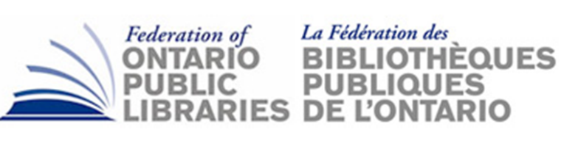
AGENDA ITEM DOC9

Subject: OMD Quarterly Report
Date: Nov. 8, 2018
Prepared by: Brendan Howley, IceBoxLogic
Prepared for: FOPL Board Meeting, Nov. 23, 2018

Brendan will be joining us on Nov. 23rd to report on the OMD.

FOPL_OMD_board report
Nov 23 2018

Show & tell

Prototype eOMD | presentation > database > insights
Prototype LDII | process + presentation > database > insights

FOPL_OMD newsroom

headline:
for debut news service, one-person pilot project with customized library micro-videos, targeting municipal elections audience, we 'put a dent in the library universe'

datapoint: three FOPL_OMD election advocacy newsletters averaged 383 downloads/newsletter from Sept 22 - October 22 2018 (direct to staff visits/reads)

datapoint: each newsletter averaging 28 reads/day or ~200 readers/week over 52% open rate across 280 library systems (staff only)

NB: Weekly publications continue; now, post-election, as of Nov 23, we've just published @ issue no. 10

Big win: videos: 22,000 views tracked Sept 22 - Oct 22 for three FOPL advocacy videos

plus

The unexpected numbers
at least 15,000+ video views reported anecdotally via word of mouth, via videos posted to PL websites or on rotation on in-library video displays

unaudited estimated reach (conservative: assumes 10 PLs out of total FOPL ecosystem) no. 1

Websites: 10 libraries w/avg. reach of 860 views/day on Facebook @ 20 days (assumes 5 out of 7 days/wk. exposure for duration of Newsroom pilot)
source: Library Digital Impacts Index data

total exposure (129,000 total views over)

unaudited estimated reach (conservative: assumes 10 PLs out of total FOPL ecosystem) no. 1

In-library: 10 libraries @ 200 patrons/day viewing: 2000 views/day @ 15 days exposure (30,000 total views)

hacked versions (unknown) at least one library hacked the three micro-videos and created a loop (estimated @15,000 exposures)

VERDICT: solid 'bang for buck' @$900 investment (from Brendan) for all three videos (at cost)

Video microcontent should be monthly initiative across entire FOPL ecosystem

next steps: production/content plan for 2019

Podcasts

Total experiment: averaged 98 full listens/week for all three (big hit: two millennial guys talking about libraries and 'fake news' @134 listens/week)

VERDICT: for unpromoted podcasts, referred solely by newsletter: a success to build on

next steps: production plan for 2019 (January implementation) for weekly 3-4min original content podcasts with 'library world' VIPs and 'people of interest'

Weekly FOPL_OMD newsletters

open rate @52% (8x industry standard for marketing newsletter e-blasts)

Library marketing staff are now using FOPL_OMD curated/branded newsletters as their PL weekly newsletter. Initial tracking: PLs adopting our content as their own weekly PL advocacy 'newshub' service.

Unexpected news: staff are using our newsletter direct, rather than as digest to draw on from for stories/images/links for social media posts

ALSO: all newsletters also shared on FOPL_OMD private Facebook page for OMD participants/alumnae/i

PLUS: fresh daily targeted library advocacy content (original: non-newsletter content for OMD alumna/i only) on FB private page @ 30views/post avg. reach. (downstream reach unknown)

Ongoing curriculum training | recruitment/referrals

Next two cohorts fully booked. Present cohort includes Ottawa PL and Mississauga Library System, two libraries we've targeted since Day One. Windsor and Kitchener PLs in queue for 2019. Word of mouth excellent amongst CEOs considering diverting staff time/talent to the program

Libraries are now rebooking us: Halton Hills (new staffer succeeding OMD alumna) and Orillia PLs (entire library staff: full day event Nov 12 2018).

Thank you.

