AGENDA ITEM

Subject: FOPL Executive Director Update based on 2017-2020 Goals
Date: March 11, 2019
Prepared by: Stephen Abram, FOPL Executive Director
Prepared for: FOPL Board of Directors’ Meeting, March 22, 2019

Once again, I am reporting my activities based on the 2017/2020 ED Goals aligned with our approved (Nov. 18, 2016) FOPL Strategic Plan 2016-2020.

My top priorities and time commitment in 2018-19 are:
- Addressing the community’s needs with respect to the new government’s policy and funding priorities
- Ensuring the stable and sustainable transfer of financial activities and other operational activities from TPL to the FOPL offices (completed).
- Managing the OMD project, Statistics, Research, and the Marketing campaigns.
- Working closely with our partners to ensure “One Voice for Ontario’s Public Libraries” and success

As we have passed our year-end, I take time for reflection on our fiscal year’s accomplishments and look forward.

I would be remiss if I didn’t thank the FOPL Board for their strong support of our activities this year. We’ve had big successes and disappointments but we are staying the course and the credit goes to Julia Merritt’s leadership and a visionary FOPL Board. I also couldn’t succeed without the support and advice of Helen Morrison, your FOPL executive assistant who makes a difference to our progress every day.

The BIG Stuff:
- FUNDING: FOPL/OLA 2018/9 revised Provincial Budget “ASK” – re-framed for the new Ontario government – heavy lobbying of Ministries and Cabinet as well as MPPs.
- Shelagh Paterson and I along with our GR Advisors met with the senior policy advisors, Cabinet Ministers and key contacts and shared a number of follow up information documents at their request.
- Municipal and Library Board resolutions and thanks supporting the “ASK”- Achieved over 46 resolutions from local councils.
- Art in Your Wallet Book! – Achieved and built with a strategy to welcome new MPPs, Councillors and Library Board Trustee members.
- Library Board Legacy Year Planning LearnHQ communication plan DONE.
- Provincial Election Toolkit (June 7) – Achieved & released.
- Municipal Election (Oct. 20) Toolkit - Achieved & released.
- Helped launch the Governance Hub online in time for new trustee appointments and orientation as well as participating in the OLBA Library Boot Camp.
- AMO, ROMA, OSUM, NOMA, etc. conference meetings attendance and trade show booths- Achieved
- Meetings held with leadership teams at AMO and AMCTO
- Meetings held with OMA, OHS, OAAG, and other cultural institutions to achieve GLAM sector alliance.
- Meetings held with the leadership team at Ontario Trillium Foundation (OTF).
- Keynote on FOPL achievements and learning at the OMA Ontario Museum Association.
- GLAM summit (ONN, OMA, OHS, SOLS, etc.) coordination presence at OMA Oct Conference
- Lobbying for First Nation Public Libraries, Ontario Digital Libraries, Public Library Program Funding Review, Community Hubs, Middle Years achieved and archived and now in process of realignment. The Culture Strategy consultations are over now but continue to inform the Ministry.
- Partnered with ORION on a broadband Pilot Initiative in the north – In process – expect $100 million broadband announcement in Thunder Bay. We have a plan of action for improving broadband in Ontario and especially First Nations, rural/small town, and the North.
- Updated Peer Measurements & Statistics for Ontario Public Libraries 2018 (2017 data) – Achieved in September (Earliest ever!). Will need to do 2018 data this summer.
- Updated Peer Measurements & Statistics for Ontario First Nation Public Libraries 2018 (2017 data) – Achieved in September (Earliest ever!).
- Working on the concept of an Ontario Digital Public Library – Content in the Pipes - there is interest with the new Minister as well as Treasury Board.
- Did CEO and second in command surveys on leadership needs, succession planning, etc.– The HR Working Group will do the analysis and gapping insights. Achieved.
- Worked with OLA and our government relations Counsel PA to realign our plans with the new government’s priorities.
- Continued our excellent collaboration with OLA et al, SOLS, and OLS-North.
- FOPL modernized all of its internal operational processes.
- Delivered on the OMD marketing and branding plan and engaged our members and communities at an increasingly higher level. The Open Media Desk (OMD) project is successfully changing the marketing culture of Ontario public libraries and providing a framework to influence our public and the government. One soundbite is that one election video received 15,000 hits at a single library system. Another system redeveloped them to appear on their screens in the library in continuous loop. OMD is building sustainable e-learning for the project as a legacy. OMD recently introduced:
  - the OMD News Room to source great content on value and impact for our members.
  - eOMD – multi-platform application to train the rest and add value to the current cohorts
  - LDII Library Digital Impact Index. We are now focused on sustainability for 2019/20.
- Created 62 slides and advertisements, 7 podcasts, 7 microvideos, etc.
- Empowered the “One Voice for Ontario’s Public Libraries” tagline and implemented the French and English reports on the website. Two websites are relevant to these activities: http://www.ThinkAboutLibraries.ca and http://www.oplw.ca
“A Visit Will Get You Thinking.” or “Une visite: ça fait réfléchir.”
- FOPL coordinated a full meeting of FOPL, OLA, SOLS, OLS-North, CULC, and CFLA to coordinate Canadian Library Month and Ontario Public Library Week.
- We continue to provide HR capacity improvements through LearnHQ, webinars, Symposia, and our social media / blog activities.
- Working with ORION as an advisory group for libraries. We were successful in getting on the program at the 2019 ORION conference.
- We were successful in supporting the CELA funding renewal along with CELA. We sent a letter of support for the 2018 & 2019 budget and it was funded. We think this will be fine in 2019 budget.
- We continue to support OLA, OSLA, and TALCO in their influencing activities for school libraries in Ontario.
2019 Opportunities:
FOPL had signed up with Girls Who Code to support your programming needs. It’s free, transformational and inspiring. Please consider adding this inita9ve to your programs portfolio.

How to Participate in Girls Who Code in Ontario Public Libraries

http://fopl.ca/news/how-to-participate-in-girls-who-code-in-ontario-public-libraries/

Buy copies of Art in Your Wallet for gifting in your meeting with your new boards, councilors and mayors.
http://fopl.ca/news/exciting-news-fopl-book-on-libraries-library-cards-and-our-value-is-available-now/
Keeping Up-To-Date with FOPL

- FOPL Website & Blog: http://www.fopl.ca
- Twitter @foplnews
- Facebook: https://www.facebook.com/Federation-of-Ontario-Public-Libraries-160173540675944/
- Facebook OMD Group: https://www.facebook.com/groups/1176265332396425/
- Stephen’s Lighthouse: http://stephenslighthouse.com/
- How? Use an RSS reader to subscribe to favourite blogs (I use Feedly – https://feedly.com/)
- LearnHQ: http://www.learnhq.ca/cms/One.aspx
- Governance Hub: https://resources.learnhq.ca/governance-HUB
- BTW ALL FOPL members are members of CFLA: http://cfla-fcab.ca/en/home-page/

Here are summaries of our major project deliverables:

FOPL OpenMediaDesk Project:

OMD News Room Update & FREE Training: All The Links to Library News Stories

The FOPL Open Media Desk project is half-way through our third year. Here’s what has happened to date and how you can participate as a FOPL member.

OMD is more than training. It’s a collegial group that co-creates great communication pieces to an FP500 standard! It’s a News Room, a source for articles, micro-videos, podcasts, and graphics. It’s also a resource for province-wide benchmarks and measurements for success. And it’s a dashboard window on Ontario’s libraries where we can co-create together and share creations, ideas and successes.

We have trained many, many groups of library staff in advanced social media engagement. We do this for no charge for FOPL members. It is a major benefit of FOPL membership and aligns with our mandate to increase the branding, marketing strength of public libraries in Ontario whilst promoting the value and economic of public libraries to Ontario residents – socially, economically, recreationally, and educationally.

We now have over 75 library systems on the program covering more than 75% of Ontario’s population! Our goal is to enrol every Ontario system! Social media is the most impactful and affordable way for us to connect with our public and cardholders to engage them in telling their stories of the impact and value of public libraries. After the training, we have discovered massive increases in engagement with social media growth in the hundreds and thousands of per cents.
In Summer 2018 we launched the OMD News Room. We provide dozens of stories each week to help you populate your social media accounts and websites. Sometimes these stories and graphics are just there for inspiration to support your marketers!

Here are some testimonials from our past cohorts who remain in the program through our private Facebook Group (https://www.facebook.com/groups/1176265332396425/). Ask to join if you’re a FOPL member. It’s a great team of people dedicated to ensuring that the message about the awesomeness of public libraries gets outside our walls and bring people inside virtually and physically.

- Brock Smith, Richmond Hill Public Library https://youtu.be/cHRNdlVe0U4
- Melanie Alderfer-Mowat, Vaughan Public Libraries https://youtu.be/_VkNSyWQHXg
- Mary Maw and Robert Simeon, Caledon Public Library https://youtu.be/1L_VUtLtW9E

2019 Training Cohort Schedule:
Each cohort requires an investment of 2 hours weekly for 6 weeks. They are done online using Zoom so you see your team and work through the projects and homework together.
Start Dates:
- Tuesday January 8, 2019
- Tuesday February 12, 2019
- Tuesday March 25, 2019
- Tuesday May 14, 2019
- Tuesday June 25, 2019
Contact sabram@fopl.ca to register.

In 2019 we will also launch:

LDii: Library Digital Impact Index

A measurement tool that allows you to compare your social media and marketing success and compare your library to others. We call this the LDii – Library Digital Impact Index. Watch for more news soon.
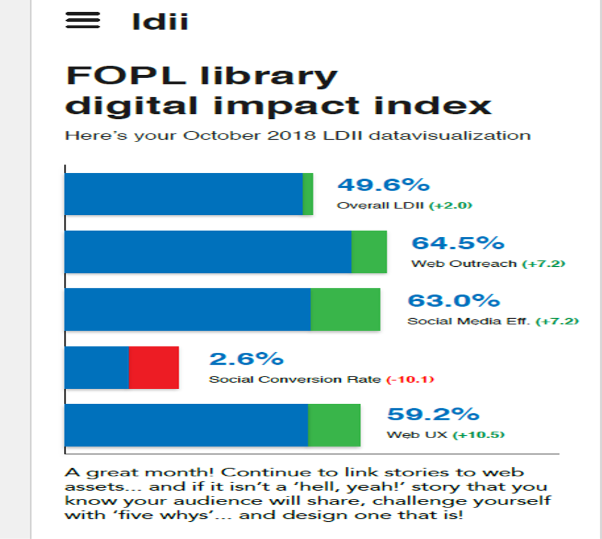

2. eOMD

An e-learning course that works on any platform or device! For those of you who have trouble joining the 6-week commitment, we will launch early in 2019 an e-learning course that delivers the training we’ve found libraries need. We call this eOMD! Here’s a sample beta outline:
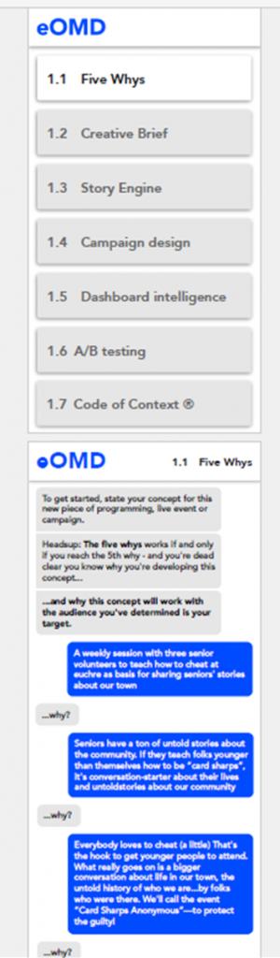
Lastly, all participants have access to:
- A provincial dashboard of their library’s social media and website metrics.
- A provincial metrics dashboard of all OMD participant library’s social media and website metrics.
- A weekly newsletter of usable stories, videos, and podcasts about public library impact and value.
- An archive of usable stories, videos, and podcasts about public library impact and value.
- Membership in a private FOPL OMD Facebook Group of OMD participants.

OMD News Room

The OMD News Room links are sent out weekly to our participant and CEO mailing list to share with marketing staff and public library members.

Podcasts

These are the links to our podcasts so far:
- Julia Merritt, CEO Stratford Public Library and Chair, FOPL
- FOPL_podcast_001_Stratford PL CEO Julia Merritt Not linking
- Nikolai and Myles, Millennials and the Public Library
- https://soundcloud.com/iceboxlogic-media/fopl-podcast-002-myles-nikolai Working
- Brendan Howley interviews Stephen Abram about the OMD Project
- https://www.dropbox.com/s/0g5xim5w7s6duit/podcast%20stephen%20abrams.aif?dl=0 Working

Archive of the short FOPL Get Out The Vote videos:

http://fopl.ca/news/fopls-get-out-the-vote-videos/
https://youtu.be/7UKrEBuJlQA
https://youtu.be/FJJx0zGl08g
https://youtu.be/DYXa_lLt4ow

Articles:
There are upcoming articles in 2019 about the OMD project in Computers in Libraries magazine as well as PLQ Public Library Quarterly.
If you’d like to register for the upcoming training sessions, please contact me and we’ll try to fit you in.

Unsolicited OMD testimonial:
Ruth Berry, Georgina PL
‘Your OpenMediaDesk training is the best I’ve training ever taken, for anything, anywhere. By far. Thank you.’

Public Library Board Development

Ontario Public Library Board Centralized Governance HUB Launched
https://www.sols.org/index.php/governance-hub
Hi-Lite: 10 Things You Need to Know as a new library board member: Understanding Public Library Board Governance in Ontario
http://fopl.ca/news/10-things-you-need-to-know-as-a-new-library-board-member-understanding-public-library-board-governance-in-ontario/

Public Library CEO Leadership Development

Made in Canada Solutions for Public Library Leadership Development
http://fopl.ca/news/made-in-canada-solutions-for-public-library-leadership-development/

Public Library Statistics and Metrics

FOPL Summary of Ontario Public Library Statistical & Metrics Projects
http://fopl.ca/news/fopl-summary-pof-ontario-public-library-statistical-metrics-projects/

The Complete List of Measurement, Metrics & Statistical Tools & Resources for Ontario Public Libraries
http://fopl.ca/news/what-are-all-of-these-library-statistics-tools-in-ontario-and-what-can-i-do-with-them/
Municipal Benchmarking Network Canada: Libraries
http://fopl.ca/news/municipal-benchmarking-network-canada-libraries/

Influencing Activities

Municipal Talking Points for Ontario Public and School Libraries
http://fopl.ca/news/municipal-talking-points-for-ontario-public-and-school-libraries/

Exciting News: FOPL Book on Libraries, Library Cards and Our Value is AVAILABLE NOW
http://fopl.ca/news/exciting-news-fopl-book-on-libraries-library-cards-and-our-value-is-available-now/

Municipal Election Toolkit: Get ready for your local election!
http://fopl.ca/news/released-municipal-election-toolkit-get-ready-for-your-local-election/

Ontario Election Toolkit
http://fopl.ca/news/the-2018-elections-are-here-be-a-voice-for-ontarios-libraries/

These are the priorities and comprise the Board direction to the Executive Director and this report shares some of our progress. We meet very regularly with Ontario politicians and civil servants including:
- Ministry of Tourism, Culture and Sport’s library roundtable on Leadership & Innovation and Community Hubs
- Ministry of Tourism, Culture and Sport’s library roundtable on Standards and Performance Measurement
- Ministry of Tourism, Culture and Sport’s library roundtable on Digital Services
- Support First Nations libraries with national and provincial advocacy
- Provided updated statistical analyses of the performance, value and impact of First Nations Libraries.
- Engaged in Federal-provincial activities regarding funding opportunities and education/library issues to address weaknesses in the support for First Nation communities and learners.
- Organized and promoted Twinning and Sponsorships for EVERY Ontario First Nation reserve public library.
- Participated in the FN Consultations with the province. Provided data and documentation.

Lastly all FOPL members are members of CFLA through FOPL and through CFLA to IFLA. We share information and updates from both on our website.

I am always available to chat and feel free to call me.

Stephen

Stephen Abram, MLS, FSLA
Executive Director, Federation of Ontario Public Libraries

sabram@fopl.ca
FOPL: 416-395-0746
Blog: http://www.fopl.ca
Twitter: @foplnews
stephen.abram@gmail.com
Cel: 416-669-4855
Blog: http://www.StephensLighthouse.com
Twitter: @sabram

