DOC 6
Federation of Ontario Public Libraries
OLS-North Truth & Reconciliation Motion
March 22, 2019 BoD Meeting

Board Motion
On Board Commitment to the First Nation Calls to Action

“The Northern Ontario Library Service Board is committed to continuing the journey of reconciliation as outlined in the Commission on Truth and Reconciliation’s (CTR) Calls for Action and the Truth and Reconciliation Committee’s Report of the Canadian Federation of Library Associations (CFLA). The Board supports the staff plan to assist municipal and First Nation Public Libraries in this journey.”

A Review of First Nation Service Opportunities which support
Truth and Reconciliation

This report mirrors that of Canadian Federation of Library Association ‘s (CFLA) Truth and Reconciliation Committee which adopts the Medicine Wheel Framework as a means of understanding the indigenous world view. The Medicine Wheel has four colours facing four directions, North, East, South and West. For purposes of looking at our services and how they support the calls for action, theses directions are represented as the following:

White Truth and Reconciliation Committee’s Calls to Action and Gaps or challenges to Services
Yellow Decolonization of space and access
Red Relationship Building
Black Environmental Scan of Best Practices

We have used the colours of the wheel as recognized by the Ojibway population which constitutes the majority of our clientele. In the Committee’s report, the colours for the east and south are reversed, likely in keeping with the beliefs of other First Nation groups.

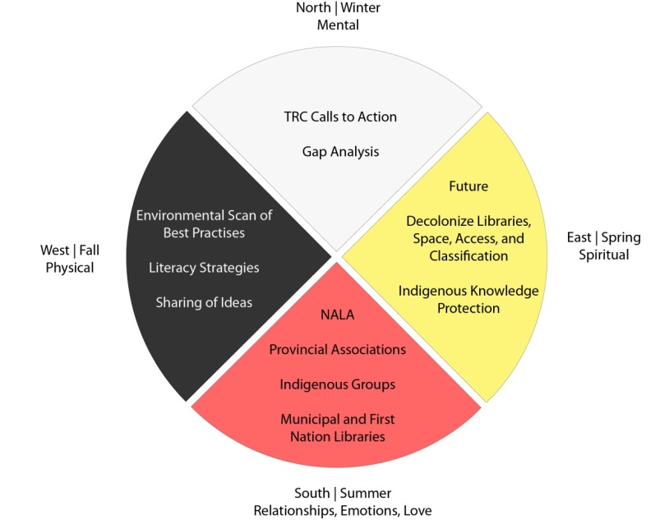

Ontario Library Service – North has provided support to First Nation Libraries for many years. The model we have used has involved a great deal of listening and consultation, but we recognize the need to continue to learn from our First Nation Stakeholders in order to work towards reconciliation.
The Truth and Reconciliation Commission Calls to Action provides a place to begin and the work of the Truth and Reconciliation Committee ensures that the library community will share this journey. The Truth and Reconciliation Commission issued 94 Calls to Action on a variety of themes including child welfare, education, language and culture, and health. The CFLA Committee took the time to study these calls to action and visualize a role for libraries in their implementation or distribution of informational results.

North

The White Sector of the Medicine Wheel traditionally represents the North, Winter, and the mental aspect of our self. Here we consider the Calls to Action themselves and the gaps needed to be addressed.

Activity | Call to Action | Means
First Nation Library Portal | Call to Action #13 and #14 | Continue to enhance and promote the First Nation Language Portal
Succession planning and recruitment | Call to Action #7 | Through our consulting and advisory services assist FN librarians in planning for succession and community recruitment
Promote knowledge of best policies and responses to TRC Calls to Action amongst First Nation Libraries | General Response to the TRC There are many initiatives already completed or underway by CFLA and others. | Through our existing lines of communication with our clients, ensure that they are aware of these initiatives and can access the results.
Assist with development of homework clubs | Call to Action #10 | Already available through consulting
Assisted with development of First Nation Collections | Call to Action #10 | Already available through consulting
Assistance with development of Community-led processes in FN libraries | Call to Action #10 | Make use of existing community development tools to advise clients on best practices in this area
Assistance in the development of storytime and programs | Call to Action #12 | Already available through consulting
Create a strategy for ongoing diversity and cultural training to OLS – North staff | Call to Action #57 | Tasked to PAL team in consultation with FN advisors.
NOLSB and OLS - North to acknowledge the traditional and territories at any public meeting or event. | Call to Action #43 | The following to be added to Board agendas and opening comments at events.

East
Traditional the East (yellow) is the direction of spring, the future, rebirth, the spiritual part of being. In this section we address one of the largest issues addressed by the TRC which is the decolonization of structures and organizations to allow First Nation people the ability to access services in a way that was free of barriers and recognizes their culture.

Activity | Call to Action | Means
Share best practices of the public library as a community hub to support awareness of cultural diversity | To promote education regarding diversity | Through advisory services and training share best practices with libraries
Promote workplace diversity hiring in libraries | Call to Action #7 | Providing recruitment support materials (job descriptions)
Encourage job shadowing between Municipal and First Nation libraries to promote understanding | Call to Action #7 | Coordinating mentorship programs
Support the decolonization of access and classification systems | CFLA T&R Committee General Recommendation #5 | Monitor broader initiatives and disseminate information to clients. Be open to assisting FN clients with alternative access systems in FN libraries. Discuss at networking meeting and facilitate a client committee to make recommendations if requested
Support the decolonization of library space in facility design | CFLA T&R Committee General Recommendation #6 | Continue to research this area and incorporate information into consultations with First Nation clients.
Develop signage in local languages | CFLA T&R Committee General Recommendation #6 | Create Signage templates in local languages for standard library requirements and by request

South

The Red sector of the wheel is about summer, love and relationships. It represents the emotional part of being. Relationships are at the heart of reconciliation. Our plan deals with relationships with other organizations, between First Nation Libraries, between municipal and First Nation Libraries and between this organization and our clients.

Activity | Call to Action | Means
Identify best practices in municipal libraries for serving local indigenous populations | Call to Action #57 | Compile best practices and make available to all libraries
Develop a resource for municipal librarians to learn about First Nation governance | Call to Action #57 | Tip Sheet created
Provide a platform to enable libraries to share stories | Call to Action #57 | Platform to be created
Share tips to encourage municipal libraries to develop partnerships with First Nation public libraries. | Call to Action #57 | Tip Sheet created
Share Maziniigan with municipal libraries to raise awareness of First Nation libraries | Call to Action #57 | Next issue released to all libraries
Encourage First Nation and municipal librarians to leverage conference as an opportunity to build relationships | CFLA T&R Committee General Recommendation #7 | Promotion to libraries
Promote sharing of First Nation collections housed in municipal libraries with the First Nation communities | Call to Action #69 | Develop a survey of FN materials available in libraries  Review results and discuss plan with FN librarians and non-First Nation Librarians how to share information
Working with SOLS, assist FN libraries with coordination of provincial projects: FN Strategic Action Group, First Nation Public Library Community and FN Community Reads | CFLA T&R Committee General Recommendation #7 | Continuation of existing committees
Provide networking opportunities for FN sharing and collaboration | CFLA T&R Committee General Recommendation #7 | Continuation of Gathering and conference meetings for First Nation clients

West
The Black sector represents fall and the physical side of being. In this case, it is the area of best practice. It looks at the things that work and how we can use them to move forward.

Activity | Call to Action | Means
Share best practices for diversity and Cultural Training | Call to Action #57 | Review best practices and identify appropriate training available
Provide Portfolio as a means of digitizing FN collection | Call to Action #14 | Finalize plan to provide Portfolio to FN clients
Provide collection development lists of historically accurate material and assist with evaluation of existing FN collections in public libraries | Call to Action #10 | Research and develop lists and make available through website.  By request, work with libraries on assessing First Nation materials.
Invite an indigenous elder to FN events and the annual conference. | Call to Action #14 | Continuation of current practice

This plan is a living document which needs to be revised from time to time. As Canada continues on the road to reconciliation there will be changes to perspectives and to structures. As things change and the needs of our clients develop and change, it will be necessary to revise this plan. At minimum it should be reviewed annually.

This plan is not meant to be a comprehensive list of our services, but rather an attempt to look at key initiatives (old and new) through the lens of this reconciliation journey.

