AGENDA ITEM DOC5

Subject: FOPL Executive Director Update based on 2019-2020 Goals
Date: March 24, 2020
Prepared by: Stephen Abram, FOPL Executive Director
Prepared for: FOPL Board Meeting, March 27, 2020

Once again, I am reporting FOPL activities based on the FOPL Strategic Plan 2016-2020 (revised Nov. 2019).
My top priorities and time commitment in 2020 are:
1. Advocacy and Influence: Ensure “One Voice for Ontario’s Public Libraries”
2. Marketing Public Library Value and Impact
3. People Capacity: Leadership Training & Development
4. FOPL Organizational Resilience

And that got thrown out the window!

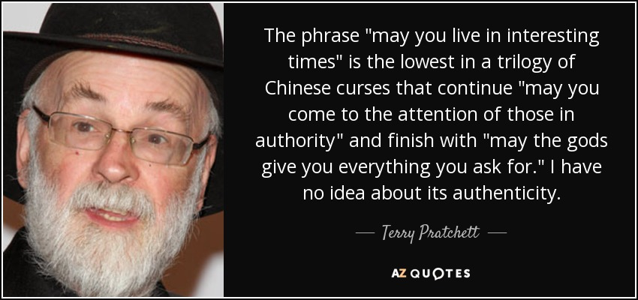

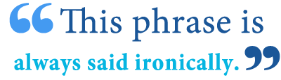

The BIG Stuff and the Short Executive Summary:
FOPL deals with Ontario public library issues - big and small - every day lately - even weekends.
It’s not an exaggeration that the past two months have been challenging! And rewarding . . . and pricklier than we imagined or planned.

The Top Priority that has upended all other is the COVID-19 Emergency where the rules and direction changed daily. We worked closely with Counsel Public Affairs to keep public libraries on the government’s radar. We see NO end of the tunnel yet and are setting our expectations that this will continue through our year-end. As policy and direction from the province dribbled out, we tried to provide context for our members.

We continue to talk with our partners and Ministries about:
- Library Boards ARE the employer and NOT subject to direct municipal control. We have a large number of questions with our Ministry about guidance on working from home, continuing to pay all or some workers, etc. so that we can help our CEOs and Boards.
- Library Boards must have authorization to hold virtual meetings – during this crisis and beyond. (Progress was made but through a drafting error school boards, police boards and library boards were left out of the rules. We hope to hear clarification this week.
- Bill 108 regulations and DC/CBC implementation. We appear to have a strong understanding with MMAH and very good 2-way communications. We’re in a winning position for libraries and some of our partners.
- As a response to COVID-19, FOPL opened the FOPL OpenMediaDesk Facebook Group to all library staff in Ontario and we populate it with a ton of resources, advice, and ideas daily. We have had many new group members and good compliments.
- FOPL is communicating on a timely basis any relevant library issues and advice (although IANAL) through our website blog, Twitter and our three Facebook groups (and through private e-mails and phone calls).
- We (FOPL, OLA, SOLS, OLS-North) meet on a weekly basis with Kevin Finnerty, ADM at MHSTCI as well as on our own to coordinate. We meet weekly with Counsel Public Affairs on all issues with a standard agenda. It is in these forums that we try to influence the COVID-19 and provincial policy issues.
- We were able to get, through Access to Information request the consulting report about the Ontario Digital Public Library (ODPL). It is important information that underpins our bigger “ASK”
- The full Ontario provincial budget is cancelled and an economic statement that will last one year will be issued digitally on March 25, 2020. We continue to position our ODPL initiative as a sustainable response to the COVID-19 crisis as well as broadband and educational initiatives.
- FOPL’s resilience is in great shape.
  - Stephen and Helen are working successfully from home. (We both can tell stories!)
  - Helen has VPN access to all of our systems at TPL and Stephen backed up every digital FOPL file on a portable terabyte drive when he thought the closure would be mandated and has it at home.
  - To our credit, Helen was successful in renewing all full members. I believe our successes lately and hopefully throughout 2020 will gain more.
  - I think we may achieve some minor savings in planned conferences that have been cancelled as well as Board meetings moved to teleconferences.
  - Our automated payroll and cheque services can continue because of the modernization changes we made last year.
  - If needed TRL security can provide access to our offices to pick something up.

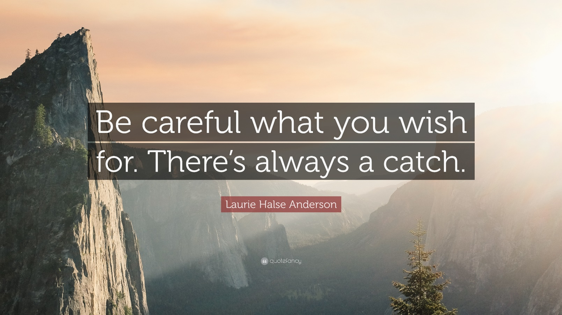

FOPL/OLA 2019 and 2020 Provincial Budget “ASK”
Update: We seem to; be adjusting on a daily basis as the budget became an economic statement and other major pools of money became places to position the public library as a great place to invest for strong eROI and sROI.
We continue to reframe our “asks” in the context of any changes in the stated priorities for the Ontario government. This presents particular challenges when their agenda may potentially seem at conflict with our own sector’s priorities and values. We continue to work on the concept of an Ontario Digital Public Library – Content in the Pipes. There is interest with our Minister, Lisa McLeod, as well as other Ministries. We continued our excellent collaboration with OLA et al and our government relations Counsel Public Affairs to continue to align our plans with the government’s priorities and consultation opportunities.

Bill 108: More Homes, More Choice Act, 2019
Update: Through FOPL’s involvement we have gotten the proposal that public libraries return to the DC charges and increased our opportunity for funding from 90 to m100%. We are also assured that our collection and other issues will remain protected in the regs as in the past. When we have full knowledge, we will implement the Hemson training.
This legislation proposes sweeping changes to the DC – Development Charge – regime in Ontario and creates a separate charge for social infrastructure funding including public libraries. These charges are called Community Benefit Charges or CBC’s for short. This legislation passed and we await the issuance of the draft regulations as well as the dates for implementation. For FOPL, this involved creating new relationships with the Ministry of Municipal Affairs and Housing. We were at the table with the senior staff at the Ministry and provided them with the data and advice needed. FOPL did member surveys on how Ontario’s public libraries used DC’s in the past and what would need to be reflected in the new CBC’s in terms of overall revenue as well as support for digital initiatives, collection growth, opening day collections in addition to Capital funds for new and renovated facilities. At this juncture, each Ontario municipality is required to update their DC Bylaw(s) by 2021 with consultations and the addition of CBC revenue collection. 2020 ACTION: FOPL has engaged Hemson Consulting to create a white paper to educate our Boards and CEOs and staff about these changes and to provide guidance to assist our members in influencing the local DC/CBC bylaws. Hemson will also provide a provincewide webinar for our members. Our only issue is the delayed issuance of the draft regulations and guidance for municipalities.

Bill 132: Better for People, Smarter for Business Act, 2019
This legislation is part of the red tape / burden reduction initiatives of the provincial government. Two of these were amendments to the Public Libraries Act. One proposed to allow Permanent Canadian Residents to be eligible for library board appointment. FOPL supported this change in the interests of potentially opening our boards to greater diversity and to align our boards with the legislation governing other provincial for profit and not-for-profit boards. The second proposal was to reduce the number of required meetings for our volunteer boards to 4 per year from 10. FOPL did a member survey on this issue and there was very strong support that this was too low. The consensus was that 7-8 required meetings was the best option and the FOPL executive director testified to the Legislative Committee in Peterborough after second reading. We were successful in making this change on third reading and now, although library boards can have as many meetings as they choose, they must have at least 7 per year.

Inter-Library Loan
Update: ILL is mostly on hold during the emergency closure period but it’s still in our Budget ask.
The changes to ILL and the budget cuts to our library services organizations – SOLS and OLS-North – caught us by surprise. It was not announced in the provincial Budget nor was it flagged as an issue by our Ministry. FOPL and OLA coordinated our response and provided the government with correct data. While the policy and cuts remained, we were able to be consulted on the move forward. For 2020 we continue to monitor this issue and restoration of ILL funding is part of our 2020 “ASK”.

ServiceOntario
Update: Still ongoing but impacted by the government work from home rles.
The FOPL Executive Director and OLA have participated in a number of discussions and workshops for the development of a new model for ServiceOntario and the role and opportunities for public libraries. We expect to continue with this engagement throughout 2020.

People Capacity in Ontario’s Public Libraries
FOPL’s People Capacity Working Group accomplished surveys of Public Library CEOs and High Potential (HiPot) leaders on leadership needs, succession planning, etc. Just prior to this Super Conference we released their report and recommendations with analysis and gapping insights.

Broadband Technology Infrastructure
FOPL continued our partnership with ORION. We are seeking government support for a library broadband Pilot Initiative in the north. We have a plan of action for improving broadband in Ontario and especially First Nations, rural/small town, and the North. We expect to see a southern pilot in 2020.

Library Funding: PLOG et al
Update: We are assured that the PLOG is safe and they are investigating earlier release.
It may be called a success in our lobbying for Public and First Nation Public Libraries That we were spared cuts to the PLOG and most other funding sources. The 2018-19 Culture Strategy consultations are over now but continue to inform the Ministry. We expect no cuts in 2020.

Ontario Trillium Foundation
Update: The project continues and we’re adjusting the strategies and meetings to accommodate COVID issues.
FOPL was successful in being award a $70,000 grant from the OTF to pilot a process for MINE: Mobile Information for Newcomer Employment. We have a wealth of partners in Kitchener-Waterloo including the local library systems. A final report is expected in Fall 2020.

Ontario Library Measurements, Rankings and Statistics
Update: We have sold four peer reports recently for libraries facing challenges from their municipalities.
I’m told they were very helpful.
We updated our popular Peer Measurements & Statistics for Ontario Public Libraries 2020 (2019 data). This is the largest report ever and we have pulled many talking points from it and shared them via the FOPL blog. We have provided a number of special custom peer reports for individual library systems to support their strategic planning, budget deliberations and priority setting and municipal challenges. These data underpin many of our proofs and talking points when dealing with the province.

CELA
Update: We have sent another letter for the 2020 Budget.
We were successful in supporting the CELA funding renewal along with CELA. We sent a letter of support for the 2019 budget and it was funded ($900K). We have also sent a letter of support for the 2020 provincial budgets. The executive director and OLA met with the new CELA executive director.

Girls Who Code in Ontario Public Libraries
Girls Who Code has now launched over 240 Clubs in 9 provinces across Canada within our first year. The largest cohort is in Ontario! FOPL signed up with Girls Who Code to support your programming needs. It’s free, transformational and inspiring. Please consider adding this initiative to your program portfolio. How to Participate in Girls Who Code in Ontario Public Libraries http://fopl.ca/news/how-to-participate-in-girls-who-code-in-ontario-public-libraries/

Art in Your Wallet Book
We built a strategy to welcome new MPPs, Councillors and Library Board Trustee members. Buy copies of Art in Your Wallet for gifting in your meeting with your new boards, councillors and mayors. It’s a great gift and continues to sell at a great price. A limited number will be at OLA Super Conference for $20 a copy! http://fopl.ca/news/exciting-news-fopl-book-on-libraries-library-cards-and-our-value-isavailable-now/

AMO, ROMA, OSUM, NOMA, etc.
FOPL attended conference meetings and staffed trade show booths. We engaged a large number of municipal councillors and senior staff about the quality, success, and impact of public libraries. We held meetings with leadership teams at AMO and AMCTO.

OpenMediaDesk
We delivered on the third and final year of our FOPL OMD marketing and branding plan and engaged our members and communities at an increasingly higher level. The Open Media Desk (OMD) project is successfully changing the marketing culture of Ontario public libraries and providing a framework to influence our public and the government. OMD is building sustainable e-learning for the project as a legacy. OMD is more than training. It’s a collegial group that co-creates great communication pieces to an FP500 standard! It’s a News Room, a source for articles, micro-videos, podcasts, and graphics. It’s also a resource for province-wide benchmarks and measurements for success. And it’s a dashboard window on Ontario’s libraries where we can co-create together and share creations, ideas and successes. We have trained many, many groups of library staff in advanced social media engagement. We do this for no charge for FOPL members. It is a major benefit of FOPL membership and aligns with our mandate to increase the branding, marketing strength of public libraries in Ontario whilst promoting the value and economic of public libraries to Ontario residents – socially, economically, recreationally, and educationally. We now have over 90 library systems on the program covering more than 75% of Ontario’s population! Social media is the most impactful and affordable way for us to connect with our public and cardholders to engage them in telling their stories of the impact and value of public libraries. After the training, we have discovered massive increases in engagement with social media growth in the hundreds and thousands of per cents. LDii: Library Digital Impact Index A measurement tool that allows you to compare your social media and marketing success and compare your library to others. We call this the LDii – Library Digital Impact Index. Watch for more news soon about. eOMD, an e-learning course that works on any platform or device! For those of you who have trouble joining the 6-week commitment, we will launch early in 2019 an e-learning course that delivers the training we’ve found libraries need. We call this eOMD! Lastly, all participants have access to:
- A provincial dashboard of their library’s social media and website metrics.
- A provincial metrics dashboard of all OMD participant library’s social media and website metrics.
- A weekly newsletter of usable stories, videos, and podcasts about public library impact and value.
- An archive of usable stories, videos, and podcasts about public library impact and value.
- Membership in a private FOPL OMD Facebook Group of OMD participants. “A Visit Will Get You Thinking.” or “Une visite: ça fait réfléchir.” Empowered the “One Voice for Ontario’s Public Libraries” tagline and implemented the French and English reports on the website. Two websites are relevant to these activities: http://www.ThinkAboutLibraries.ca and http://www.oplw.ca FOPL coordinated with OLA, SOLS, OLS-North, CULC, and CFLA to coordinate Canadian Library Month and Ontario Public Library Week.

LearnHQ for Library Boards
Update: SOLS has made this free to all libraries in Ontario so staff can take training from home during the physical closures.
FOPL helped build new learning modules based on the 4-year Board cycle under a government grant. We participated in the launch and promotion of the Governance Hub which provide open access (paywall and password free!) for Ontario’s volunteer library board members.

FOPL Resilience
FOPL modernized all of its internal operational processes. We invested your membership dollars well. We again have a clean financial audit review for you – as always.
- We continue to provide HR capacity improvements through LearnHQ, webinars, Symposia, and our social media / blog activities.
- We continue to support OLA, OSLA, and TALCO in their influencing activities for school libraries in Ontario.
Reward for reading to the end: 