HANDLING PROCEDURES & CHECK-IN FOR MATERIALS
DURING PANDEMIC EVENT

Standard Operating Procedure #3

Isolation of Returned Items

- All items that have been returned once libraries reopen must be isolated for 48 hours as determined by the Institute of Museum and Library Services (IMLS).
- Each location must establish an isolation area for these items. This should be an area that does not require regular access by staff or the public. This location will be maintained specifically for the isolation of items until further notice.
- Minisorters and internal bookdrops will be blocked off and not be accessible to customers for as long as the isolation of materials last. This will prevent materials from entering the workrooms before they are isolated.
- Minisorters will be available for use by staff only for checking in previously isolated items.

Bookdrop
- Staff must be trained in and wear appropriate PPE – gloves (mandatory) and masks (recommended)
- Items should be handled as little as possible. Only once, if practicable, depending on # of available carts/baskets/volume of material.
- If at all possible, exterior bookdrops should be emptied only once per day, at a consistent time that works for that branch.
- Cart or basket should be brought to the bookdrop and items loaded safely. Handle only as many items at a time as can be managed without touching your chest, belly, or clothing (see example):
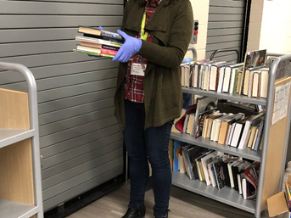

  - If possible, cart/basket should be wheeled to isolation area and labelled with the date. If there are no sufficient carts/baskets in the branch, then materials should be loaded safely onto tables, again only as many items at a time as can be managed without touching your chest, belly or clothing. Once unloaded, the items on the table should be marked with the date. The cart or basket used to transport the materials should then be disinfected.
  - Staff member should remove PPE and dispose of it properly, then wash hands.
  - Process to be repeated the following day, with newly returned items never coming into contact with previously returned items.

Check-in of Isolated Materials

- Staff must be trained in and wear appropriate PPE – gloves (mandatory) and masks (recommended)
- After 48 hours, materials are considered virus-free. Staff will then retrieve the items returned from the isolation area and process as normal.

May 2020 Page 1 of 1

