Appointment of Director of Library Services

May 27, 2020

For Immediate Release:
At its meeting today, the Bruce County Public Library Broad announced the appointment of Brooke McLean as the new Director, Library Services for Bruce County. Brooke joined the County of Bruce as the Assistant Director, Library Services in November 2018 and assumed the Interim Director role in February 2020. Brooke came to Bruce County with over 15 years of service with Wellington County Library Services, where she acted in various roles including Information Services Librarian and Branch Supervisor. Brooke holds a Bachelor of Arts in Social Development Studies and a Master of Library and Information Studies.
Since coming to Bruce County Brooke has been actively engaged in delivering excellent services through the County’s Library system. She has great passion for providing services to families and children and is looking forward to enhancing library services across the County. As of late, she has been active in supporting the delivery of electronic services to county residents in response to restrictions imposed by the COVID-19 pandemic.
“We are excited to welcome Brooke into this leadership role with Bruce County Library services. Brooke demonstrates great passion and interest in the provision of library services for all residents of the county. She will effectively lead our library team in exploring new and changing ways of providing services” says Luke Charbonneau, Chair, Bruce County Public Library Board.
On taking on this new role, Ms. McLean shares that “I am pleased to be taking on this new role with Bruce County Public Library and providing leadership to important library services across Bruce County. I am passionate about the role that libraries play in developing robust communities by providing literacy, technology, and social resources and look forward to charting the course for library services moving forward.”
Ms. McLean will begin her role on June 1, 2020.

Bruce County Library Services:
In partnership with local municipalities and under the direction of the Bruce County Public Library Board, Bruce County Library services provides resource lending, literacy programs and related services in 17 locations across the County of Bruce.
Although branches have been and remain closed to the public at this time, Bruce County Public Library is moving forward with a service that will allow patrons to safely borrow materials from all 17 branches without entering the buildings. Starting on Tuesday, June 2nd, library patrons will be able to place orders for Curbside Pickup by calling or emailing their local branch, or by filling out a form on the library website.
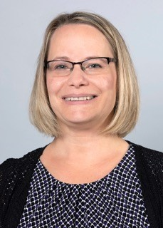
-30-
For more info:
Mayor Luke Charbonneau – Town of Saugeen Shores
Chair – Bruce County Public Library Board
519-832-2008
LCharbonneau@brucecounty.on.ca

Sandra Datars Bere
Chief Administrative Officer
Corporation of the County of Bruce
519-881-1291
www.brucecounty.on.ca
SDatarsBere@brucecounty.on.ca

