Date: Jan. 5, 2017
Prepared by: Stephen Abram Executive Director
Submitted by: Pam Ryan, Julia Merritt, Kathy Fisher
Subject: FOPL Nominations Committee Report

The Nomination Committee was struck by the Board of Directors in November 2016 and tasked with searching for new member volunteers for the FOPL Board to be confirmed by the Members at the 2017 Annual General Meeting.
As directed, the Committee composed of Pam Ryan, Julia Merritt, and Kathy Fisher proposes to the FOPL Membership the following slate to fill the open positions.
Motion: That the Members approve this slate of Directors to fill the open positions in the FOPL Board of Directors.
Moved by: FOPL Nominations Committee
Seconded:
Francophone Caucus:
One CEO: Christina Blazecka, CEO, Cochrane Public Library

Small-Medium Library Caucus:
Two Trustees: Pierre Giroux, Grimsby Library Board and Paul Nicholls, Trustee from Georgina
Northern Caucus:
One CEO: Rebecca Hunt, Library CEO/Head Librarian, City of Temiskaming Shores Public Library

TPL Caucus:
Two staff: Vickery Bowles will remain. Two Directors have put their names forward for the other position. TPL will select in January.
Two Trustees: Paul Ainslie will remain. Dianne LeBreton is stepping down. TPL will replace her with another Trustee in January.
Paul Nicholls FOPL Director Application
Name: | Paul Nicholls
Telephone: | 905-251-4441
E-Mail: | paul.e.nicholls@gmail.com
Website: | paulnicholls.com
Biography
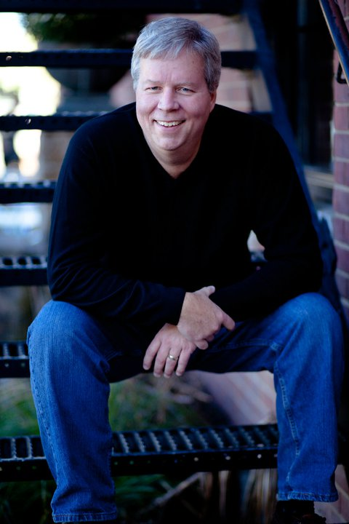

Paul has lived in Georgina since 1990. After a lengthy career building a computer software company specializing in municipal government, he sold the company in 2003 and has continued his career working with several companies in the technology sector. In addition to his current consulting practice, he is also a part owner in a mobile clothing company with his wife.

He has held an elected Town Council position, and currently serves his community as Chair of the Georgina Public Library System, director of the South Lake Community Futures Development Corporation, director of Georgina Cares (a local children’s charity) and hosts a show on the local Rogers cable station, Politically Speaking.

He also holds a Distinguished Toastmaster designation.

He has four children Ryan, Kylie, Kelsey and Ashley, and makes his home in Baldwin with his wife Jenny.

Pierre Giroux

I am interested in serving on the Board of the Federation of Ontario Public Libraries. I am a retiree from Algonquin College in Ottawa where I worked for 30 years as a teacher, academic manager, planner and staff trainer. I also worked with the Association of Colleges of Ontario as a facilitator for the Governance Orientation program and the Management and Leadership program.

After retirement from Algonquin College (2000) I worked as a consultant in strategic planning and human resources development for a range of national and international organizations.

Over the years, I have served on a number of Boards, including as a governor with Algonquin College, a trustee and sponsor with the Colleges of Applied Arts and Technology Pension Plan, a director with Centraide of Western Quebec, a director and chairperson with the Gatineau Centre for Social Services.

I have completed a Master Degree in Social Work (University of Michigan) and a Master Degree in Public Administration (Ecole Nationale d'Administration Publique).

Overall I consider myself to be a life-long learner, fluent in both English and French and with experience and expertise in strategic planning, facilitation of learning, governance, management and leadership.

I currently reside in Grimsby Ontario and serve on the Grimsby Library Board. I live with my wife Dale Shipley at 22 Morrison crescent.L3M5K4 and can be reached at 905-309-8637. My e-mail address is giroux_pierre@hotmail.com.

I will be able to attend the AGM on February 2. Please let me know if you need any more information and I will be looking forward to meet you and your colleagues if you decide to appoint me as a Board member of the FOPL.

Regards and best wishes for the Holiday season.

Pierre Giroux

Rebecca Hunt biography

Rebecca Hunt
Work Address:
Temiskaming Shores Public Library
Box 2090, 545 Lakeshore Rd. S.
Haileybury, ON P0J 1K0

Haileybury Branch: 705-672-3707
New Liskeard Branch: 705-647-4215
rhunt@temiskamingshores.ca

I have been the Library CEO at Temiskaming Shores Public Library in Haileybury and New Liskeard for the past eleven years, having moved to Ontario from Nova Scotia in January 2006 for this position. I have a Master’s degree in Library and Information Studies from Dalhousie University and 17 years’ experience working in public, school and university libraries in Alberta, Nova Scotia and Ontario. I also completed a certificate in the Management of Non-profit Organizations from Ryerson University in the fall of 2015. I founded a library networking group in Northeastern Ontario called the Northern Lights Library Network in 2007 and continue to chair this organization. I am also co-chair of the Leave a Legacy Temiskaming organization, and a member of the board of directors for the Conseil des arts Temiskaming Arts Council. Current large library projects for Temiskaming Shores Public Library include participation in the Near North Mobile Media Labs Digital Creator North project (http://www.n2m2l.ca/digital-creator/ ) and participation in Ontario Library Services North library value study. I enjoy living in Northern Ontario and take advantage of the hiking, camping, canoeing, cross-country skiing and skating available to us here with my husband and two daughters.

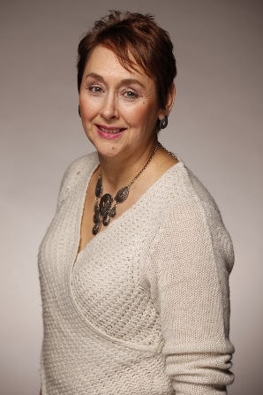
Christina Noël-Blazecka
Christina was born and raised in Cochrane, Ontario and has been the CEO of the Cochrane Public Library since 2009. She comes from a management background co-managing the family greenhouse business growing tree seedlings for the Ministry of Natural Resources, nuclear seed potatoes for the Ministry of Agriculture, and bedding plants for the community for the past 30 years. She graduated from Ryerson University in Hospitality, Tourism, Management after which she worked with a local Chartered Accounting firm providing bookkeeping and auditing services to far Northern Ontario communities during the greenhouse off season. Christina also worked for the District School Board Ontario Northeast in financial and secretarial/librarian capacities. She has since acquired her EXCEL certificate in managing a small northern library.
She is deeply involved in her community from park and gardening projects to Winter Carnival and Summerfest activity planning. She served for 3 years, up until recently, on the TVO Regional Councillors Advisory Board, was also a member of the Cochrane Board of Trade for 3 years, developed and Chaired the Commando Park Committee, provided multiple years of service with the Cochrane Horticultural Society, and sat on several Parent Councils throughout her children’s school days.
Christina looks forward to working closely with the Federation of Ontario Public Libraries to offer a voice for Northern Ontario public libraries as we move forward in this exciting time where libraries become more recognized for their services as community hubs.

