The Economic Impact of
Vaughan Public Libraries
On the City of Vaughan
Background:
In 2013 Toronto Public Library conducted an economic impact study with the Martin Prosperity Institute. The results of that study clearly demonstrate the far reaching value and impact of the library. The TPL study was the first Canadian public library study to measure in concrete economic terms the Return on Investment for library service.
Given the impressive numbers seen in TPL’s economic impact report, VPL has used the same methodology to evaluate the economic impact of VPL on the City of Vaughan.
The results were equally impressive. This report is a summary of the findings from the TPL study, using VPL data. All credit for the value of this study goes to Martin Prosperity Institute.
For more information on the methodology used by Martin Prosperity Institute please refer to the Toronto Public Library Economic Impact report: http://martinprosperity.org/media/SoMuchMore-accessible.html

Summary of Findings:

Vaughan Public Library Delivers $5.95 of Economic Impact for Every $1 Spent, for a total economic impact of over $80 million
The results of Vaughan Public Library’s economic impact demonstration clearly indicate that Vaughan Public Libraries delivers a strong Return on Investment, through the delivery of library services that enhance Vaughan’s competitiveness and prosperity and contribute to a better quality of life for all.
For every dollar invested in Vaughan Public Libraries (VPL), Vaughan residents receive $5.95 in value. This benefit results from the market value of services delivered, or direct tangible benefits and the stimulus to Vaughan’s economy from direct spending and re-spending (indirect tangible benefits).

Vaughan Public Libraries creates over $57 million in Direct Tangible benefits
Direct tangible benefits represent a conservative measure of the market value of the services used. Direct spending represents spending that directly impacts Vaughan’s economy and is the total funding received from the City of Vaughan. Indirect tangible benefits represent the re-spending by those who are paid by the direct spending within Vaughan’s economy.
The Direct Tangible benefits can be broken down as follows:
- Collection Use: $48 million (including in-library use) - see Summary Economic Impact Tab and Exhibits 1,2, and 3
- Programs: $972,970 – see Exhibit 4
- Reference & Database services: $4.4 million – see Exhibit 5
- Technology Access: $2 million – see Exhibit 7
- Meeting & Study space: $1.4 million - see Exhibit 8
Graph 1 below shows the breakdown of the total economic impact from the library. Direct tangible benefits for individual library services are provided along with the total direct spending and total indirect tangible benefits. Just over 60% of the total impact is from providing free access to books and other items of the VPL collection. The remaining total impact is divided between the value of the other library services, total direct spending, and the indirect tangible benefits created by the direct spending.

Graph 1
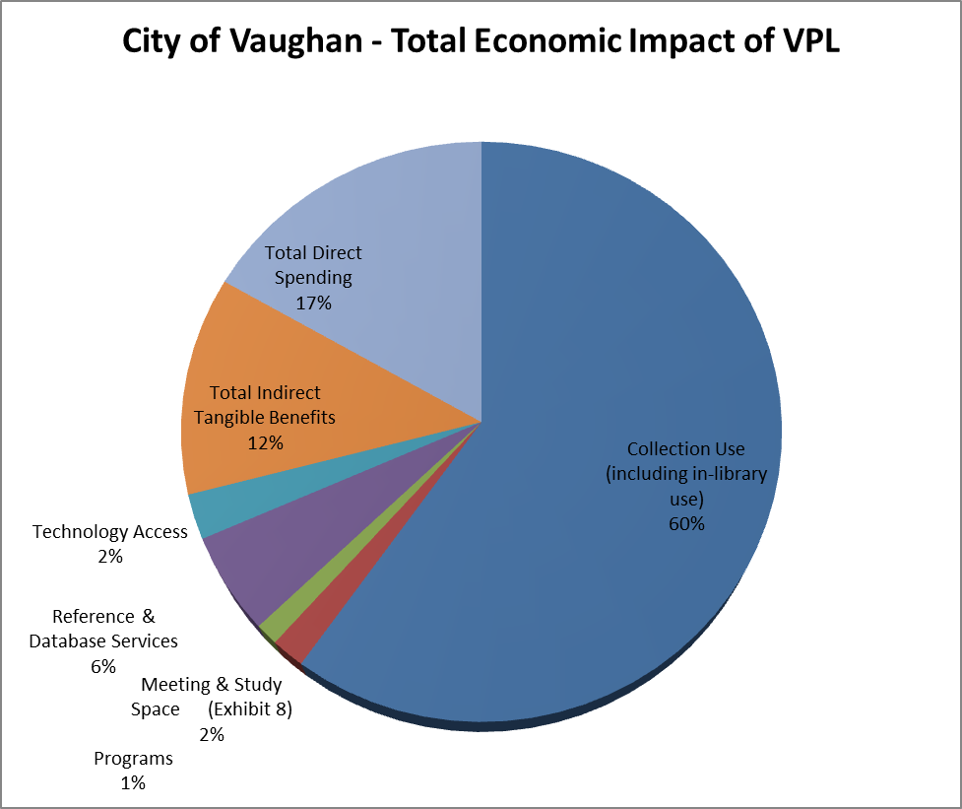
What does this value mean per resident? – see Exhibit 9
- VPL’s value per HOUSEHOLD in the City of Vaughan is $849
- VPL’s value per RESIDENT in the City of Vaughan is $259
- VPL’s value per Card holder in the City of Vaughan is $617

What does this value mean per open hour? – see Exhibit 10
- The average open hour at a branch generates $2,673 in direct benefits
- Total value of all library hours in 2013: $52.5 million
- Average value of one open hour: $2,673
- Average cost of one open hour: $645

The analysis shows that on average one open hour at any of VPL’s 7 branches generates $2,673 in direct benefits that are only possible because that branch is open. Exhibit 9 summarizes the average benefit of a branch being open for one hour. The $52.5 million in benefits is only those direct tangible benefits that require a branch to be open in order for the specified services to be available. In 2013, VPL branches were open for approximately 19,650 hours. Given $12.7 million (minus capital and eTitles) in direct spending used to fund those benefit-generating services, the average open hour costs approximately $654. Therefore, the average benefit is over 4 times the average cost.

Return on Investment is 495% - see Appendix 9
The return from the City of Vaughan’s investment in Vaughan Public Libraries is 495%, which is the midpoint of a range very conservatively estimated to be 219% and is comfortably shown to reach 771%. Exhibit 14 shows this range, as well as the itemization for the direct tangible benefits, direct spending, and indirect tangible benefits.
Vaughan residents receive $57 million in direct tangible benefits from services used by residents across the city. Annually, Vaughan Public Libraries spends nearly $13.5 million for direct spending – see Exhibits 10- 13. Vaughan Public Libraries generates $9.8 million in indirect benefits to Vaughan’s economy from library spending on infrastructure to improve local branches, collections to provide access to reading, and staff to support service delivery.
The total economic impact and impact per dollar spent are impressive results, and are in the same range of values found in published studies of other library systems from around the world.
A Note about Intangible Benefits
In addition to the impressive numbers, VPL provides vast intangible benefits which are not calculated as part of this report.
Vaughan Public Libraries delivers services that contribute in many ways to the City’s goals for economic growth and prosperity, and generate intangible benefits which do not have an easily quantifiable value, but create significant value for residents. This value includes opportunities for residents to improve their literacy skills, enhance their educational and employment opportunities, and improve quality of life for themselves and their families through library collections, services and programs. These outcomes deliver a lifetime of value to residents and increase the economic competitiveness and prosperity of Vaughan. The library’s strategic alignment with the City’s plans for economic growth, combined with conditions that support livability and quality of life for residents, create an attractive climate for business investment and support a sustainable cycle of prosperity.

Summary Chart:
 |  | Low* ($) | Estimate* ($) | High* ($)
Direct Tangible Benefits | Collection Use | 16,049,620 | 48,148,861 | 80,248,102
Direct Tangible Benefits | Programs |  | 972,970
Direct Tangible Benefits | Reference & Database Services |  | 4,476,350
Direct Tangible Benefits | Technology Access |  | 2,020,950
Direct Tangible Benefits | Meeting & Study Space |  | 1,420,897
Direct Tangible Benefits | Total Direct Tangible Benefits |  | 57,040,029
Direct Spending | Operations |  | 1,748,000
Direct Spending | Capital (Annual Average) |  | 656,036
Direct Spending | Employment |  | 9,768,419
Direct Spending | Materials |  | 1,765,000
Direct Spending | Total Gross Spending |  | 13,937,455.
Direct Spending | Revenue Offsets to Costs |  | 440,057
Direct Spending | Total Direct Spending |  | 13,497,398
Indirect Tangible Benefits | Operations | 699,200 | 1,223,600 | 1,748,000
Indirect Tangible Benefits | Capital (Annual Average) | 262,414 | 459,225 | 656,036
Indirect Tangible Benefits | Employment | 3,907,367 | 6,837,893 | 9,768,419
Indirect Tangible Benefits | Materials | 706,000 | 1,235,500 | 1,765,000
Indirect Tangible Benefits | Pages Employment Experience Benefits | 24,674 | 43,180 | 61,686
Indirect Tangible Benefits | Total Indirect Tangible Benefits | 5,599,657 | 9,799,399 | 13,999,142
Total Economic Impact |  | 43,090,578 | 80,336,827 | 117,621,529
Impact per Dollar Spent |  | 3.19 | 5.95 | 8.71
Impact per Toronto Resident |  | 139 | 259 | 379
Impact per Toronto Household |  | 455 | 849 | 1,244
Total Benefits |  | 29,593,180 | 66,839,428 | 104,124,130
Return on Investment |  | 219.3% | 495.2% | 771.4%
Average Value of One Open Hour at a Branch |  |  | 2,673

