CFLA-FCAB Indigenous Matters Committee
Charter

Mandate
The Committee on Indigenous Matters exists to and work with Indigenous (First Nations, Metis and Inuit) people in address issues related to libraries, archives and cultural memory institutions; to promote initiatives in all types of libraries by advancing and implementing meaningful reconciliation as addressed by the Truth and Reconciliation Commission report and in the Calls to Action (http://www.trc.ca/websites/trcinstitution/File/2015/Findings/Calls_to_Action_English2.pdf) {http://www.trc.ca/websites/trcinstitution/File/2015/Findings/Calls_to_Action_French.pdf}; to implement the recommendations of the CFLA-FCAB Truth and Reconciliation Committee report; to monitor ongoing progress in those areas; and to promote collaboration in these issues across Canadian libraries, archives, and cultural memory institutions.
The specific recommendations of the CFLA-FCAB Truth and Reconciliation Committee are reproduced below, for reference. The actions described in recommendations 1 and 2 were completed prior to the chartering of this committee—action must still be taken on recommendations 3-10.
CFLA-FCAB Truth & Reconciliation Committee Recommendations:
- As CFLA-FCAB is a national voice with the ability to influence national and international policy regarding issues of importance, we request the CFLA-FCAB create a permanent Standing Committee on Indigenous Matters utilizing the medicine wheel framework developed by the Truth & Reconciliation Committee;
- The T&R Committee supports and endorses the CFLA-FCAB Position Statement on Library and Literacy Services for Indigenous (First Nations, Métis and Inuit) Peoples of Canada;
- Encourage libraries, archives and cultural memory institutions to implement the Truth and Reconciliation Commission of Canada 94 Calls to Action, several of which have been identified as having a direct impact on libraries and archives and are prioritized in this report, and to implement a status report on a yearly basis to monitor their implementation;
- Ensure accessibility moving forward by continually reminding stakeholders that material produced and programming planned in the future should be accessible to all Canadians. CELA (the Center for Equitable Library Access) and NNELS (the National Network for Equitable Library Service) are positioned to support these efforts.
- Decolonize Access and Classification by addressing the structural biases in existing schemes of knowledge organization and information retrieval arising from colonialism by committing to integrating Indigenous epistemologies into cataloguing praxis and knowledge management;
- Decolonize Libraries and Space by recognizing and supporting Indigenous cultures, languages and knowledges through culturally appropriate space planning, interior design, signage, art installations, territorial acknowledgements of geographic-specific traditional territories and public programming in collaboration with local Indigenous stakeholders;
- Enhance opportunities for Indigenous library, archival and information professionals as well as the inclusion of Indigenous epistemologies in the Canadian library and archives profession through culturally appropriate pedagogy, recruitment practices, professional and continuing education and cross-cultural training in collaboration with local Indigenous stakeholders and partners;
- Recommend the implementation of Indigenous Knowledge Protection protocols and agreements with local and other Indigenous groups who have holdings in libraries, archives and/or cultural memory institutions to respect the Indigenous cultural concept of copyright with regard to Indigenous history or heritage, which is often located in but not limited to oral traditions, songs, dance, storytelling, anecdotes, place names, hereditary names and other forms of Indigenous knowledges; recommend that CFLA-FCAB actively participate in reforming the Canadian Copyright Act to include protection of Indigenous knowledges and languages while advocating for changes to include traditional knowledge as outlined and recommended by the World Intellectual Property Organization (WIPO) – Intergovernmental Committee on Intellectual Property and Genetic Resources, Traditional Knowledge and Folklore (http://www.wipo.int/tk/en/igc/). We join the Truth and Reconciliation Commission (TRC) in calling upon Library and Archives Canada to implement the Truth and Reconciliation Commission Calls to Action #69 (Appendix D) by fully implementing the United Nations Declaration on the Rights of Indigenous Peoples (UNDRIP) http://www.un.org/esa/socdev/unpfii/documents/DRIPS_en.pdf and the Updated Set of Principles for the Protection and Promotion of Human Rights through Action to Combat Impunity (2005), more commonly known as the Joinet/Orentlicher Principles http://www.derechos.org/nizkor/impu/principles.html;
- Establish an online database of “living documents” to highlight existing Best Practices of Indigenous Services in libraries, archives, and cultural memory institutions that will serve as a foundation to help disseminate those best practices and for this “living document” to be updated preferably on a quarterly basis but minimally semi-annually;
- Maintain a database of Indigenous organizations or groups committed to preserving cultural memory primarily, but not limited to, libraries, archives, language preservation, cultural history/museums to build relationships; to support the development of an Indigenous association of library, archives and cultural memory institutions; and to support in principle the National Aboriginal Library Association (NALA) regarding their stated intent of developing First Nations public libraries on reserves.

Responsibilities
The Indigenous Matters Committee will be organized by utilizing and adapting the medicine wheel framework under the guidance of elders and traditional teachers as a framework through which the Indigenous worldview can be understood. 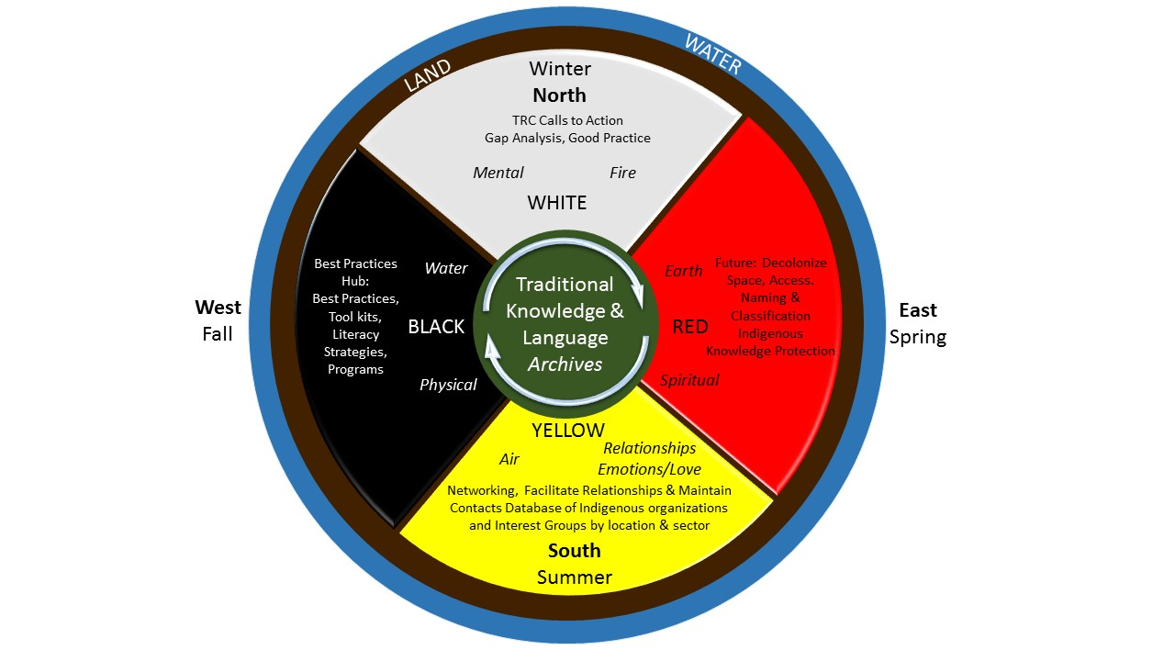

Outcomes
To fulfill its responsibilities, the Committee will deliver the following with the support of the CFLA-FCAB Manager and others as required:
- The creation and maintenance of the CFLA-FCAB Indigenous Hub and the databases therein; identifying and promoting best practices to work with Indigenous people and communities; promote education with the library, archival and cultural memory profession regarding Indigenous issues, to promote and support implementation of the Truth & Reconciliation Commission Calls to Action, and to advocate on behalf of Indigenous people and communities in regard to libraries, archives and cultural memory institutions. This database will be updated on a quarterly basis.
- Engaging with other CFLA-FCAB Committees and Working Groups as needed to ensure an Indigenous perspective is taken on matters of concern to Canadian libraries, archives, and cultural memory institutions.
- An annual report on progress made to the CFLA-FCAB AGM.

Procedural Rules

Members
The Chair of the Committee will be the Indigenous Representative to the CFLA-FCAB Board of Directors. If the Chair ceases to be a member of the Board through the processes described in CFLA-FCAB’s Bylaws, the Committee will be responsible for nominating the new Indigenous Representative from among its eligible members.
The Vice-Chair will be appointed from among the members of the Committee.
Members of the Federation will nominate members to serve on the Committee.
Additionally, the Chair may invite other individuals to join the committee who have the required knowledge or relevant experience, including Indigenous individuals and Elders who can represent their community, or representatives of groups including an ex-officio members from Library & Archives Canada; Canadian Museum Association; CELA (the Center for Equitable Library Access); NNELS (the National Network for Equitable Library Service); CFLA-FCAB Copyright Committee and other as needed to complete its work.

Meetings

The entire committee will meet 10 times a year. Subcommittees will also meet 10 times a year, on a staggered schedule. Meetings will be via electronic means such as teleconference, or online.

Minutes
Minutes of each meeting shall be kept and circulated to the members of the Committee, CFLA-FCAB’s Manager, and the Chair of the CFLA-FCAB Board of Directors.

Recommendations and Reports
Committee recommendations and reports will be submitted in writing to the CFLA-FCAB Board. Documents will include both suggested action and justification for the recommendations. The Chair of the Indigenous Matters Committee or other designated representative of the Committee will be invited to attend any session during which recommendations pertaining to Indigenous people and/or reports are scheduled to be discussed.

Revision of the Mandate
The Committee will review its mandate every 2 years and seek appointments/re-appointments from the member associations and may recommend Charter revisions to the CLFA-FCAB Board.

