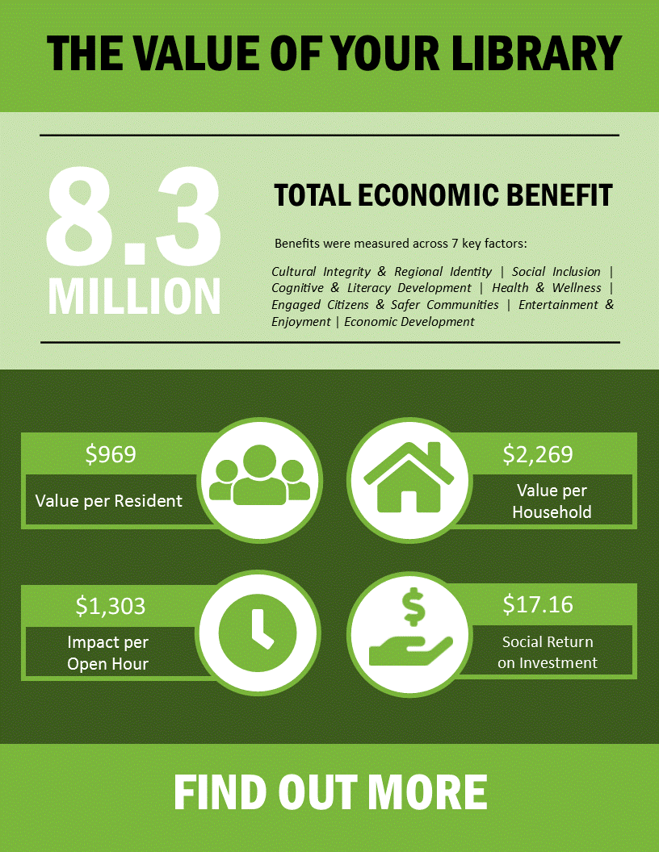

Fort Frances Public Library Technology Centre

Social and Economic Return on Investment Report

Executive Summary
Public libraries serve their communities as centres of information, art, technology, history, and community life. They compete for scarce public funding along with other community institutions. Small and rural Northern libraries are increasingly challenged to explain their value in the community amid mounting municipal priorities. In addition, funding organizations request that grant applications identify outcomes that will be achieved through the funding. As this becomes more prevalent, libraries are under pressure to define and use outcome based analytics. Small northern libraries need the capacity to define, assess, and report on outcomes or return on investment.
We recently undertook two studies in order to demonstrate the value we offer our community. We examined the social and economic returns on investment gained through funding our services. Through the identification and valuation of our services we have identified that our social return on investment is $17.16 for every municipal dollar spent. The economic return on investment per dollar spent is $7.32. Beyond the dollars and cents, we help to make Fort Frances a community. One community member recently commented that “[the Library] is the first place our family felt at home and welcomed when we first moved to Fort Frances.”

Social Return on Investment
Libraries provide many benefits to the communities they serve. This report attempts to calculate the value of those benefits in dollars and cents. Through this study we discovered that for every dollar spent by the Town of Fort Frances on its library in 2017, the community received $17.16 in benefits. For every hour we were open, we generated $1,303 in benefits. This can be contrasted with the per hour cost to run the Library, which is $162. Additionally, the social impact for each household was $2,269 in value.

What is Social Return on Investment?
Social Return on Investment (SROI) uses a cost-benefit analysis approach to assessing social services. It measures the impact and value of social investments that have been made within a community. To be effective, an SROI needs to be tailored to the service it is measuring. Developing the methodology for an SROI study is costly and time-intensive, however through the Ontario Libraries Capacity Fund Ontario Library Service – North (OLSN) was able to secure two years of funding in order to develop a toolkit able to measure the SROI of northern, rural, and indigenous libraries. Through the funding, OLS-N was able to hire consultants from the NORDIK Institute to develop the study.

Valuing Northern Libraries
Based on a review of relevant literature, focus groups, consultation and site visits, NORDIK designed a measurement tool to encompass the many diverse and unique roles that public libraries play in the North as community hubs. Seven key areas were identified as components of libraries’ benefit to their communities, namely: Cultural Integrity and Regional Identity, Social Inclusion, Cognitive and Literacy, Health and Wellness, Engaged Citizens and Safer Communities, Entertainment and Enjoyment, and Economic Development. Three indicators were chosen within each sector that best reflect how libraries’ operations and expenditures contribute to each respective area. The data for each is typically already collected by libraries or is otherwise accessible through library data collections methods.

Cultural Integrity and Regional Identity
We support the cultural integrity and identity of Fort Frances through our collections and services. This includes our local history collection and Tackleshare program. We contribute to a sense of community in Fort Frances. When asked in a recent survey to provide examples of how they felt we provided a positive contribution to our town, nearly half of respondents replied that we provided a sense of community.
Table 1: Cultural Integrity & Regional Identity Benefit
1. Cultural Integrity & Regional Identity Indicators | Economic Benefit
Economic benefit of special collections and other materials related to culture and history of area (incl. snowshoes, fishing rods, GPS, and Indigenous, French, and Immigrant languages) | $43,915
Economic benefit of the promotion of local cultural and historical events, programs, advertising space and information services about local area | $14,175
Economic benefit of cultural events | $15,120
Total economic benefit of Cultural Integrity & Regional Identity indicators | $73,210
The economic benefit we generated in 2017 through our services and activities related to cultural integrity and regional identity totals $73,210 based on the SROI indicators.

Social Inclusion
Libraries are key community sites for fostering social inclusion, for providing services that can serve to equalize skill levels, and for fostering relationships of mutual support and trust (see Rao 2012; Rankin 2012; Rosenfeldt 2006). We are no exception, with one member commenting recently that “[the Library] is a safe, welcoming and quiet space for community members to participate in learning and activities. It's for all ages. It's free and accessible!” We also perform a vital role in keeping our seniors connected to each other and the broader community through our book delivery service.
We offer free access to computers and Wi-Fi. The internet has become a crucial part of our every day lives; but not everyone can afford internet access at home. Our computer and Wi-Fi services are available to everyone, regardless of whether or not they are library members. Similarly, membership is not required to attend any of our programs. By broadening access beyond library members to the whole community we are able to ensure that everyone can access the public library as a shared commons.
Table 2: Economic benefit of Social Inclusion
2. Social Inclusion | Economic Benefit
Economic benefit of accessible collections, (i.e., Braille, large print books, Talking Books on CD, etc.) | $302,952
Economic benefit of inter-library loans | $8,042
Economic benefit of internet access | $122,490
Total economic benefit of Social Inclusion indicators | $433,484
The economic benefit we generated in 2017 through our services and activities related to social inclusion totals $433,484 based on the SROI indicators.

Cognitive and Literacy Development
Research shows that adults with low literacy levels have more health problems, earn less and live shorter lives than other adults (Canadian Council of Learning 2010). We address literacy and cognitive development in a variety of ways, ranging from the provision of materials that cater to multiple forms of literacy to programming that creates positive associations with reading and literacy.
We provide a number of programs designed to develop pre-literacy skills. After-school and summer reading programs assist with the continuation of literacy skills development outside of school. Class visits to the Library foster not only a love of reading, but a love of the Library as well. As one patron commented “My children love the library, they offer so many wonderful activities for the kids and we try to utilize as many of the programs offered that we can. Living in a small community it's nice to have programs offered for children and teens.”
Table 3: Cognitive & Literacy Development Benefit
3. Cognitive & Literacy Development | Economic Benefit
Economic benefit of children and youth circulation (incl. books, audio books, DVDs, databases and other materials directed at this age | $357,028
Economic benefit of children and youth programming | $80,805
Economic benefit of class instruction at a library or a school | $95,850
Total economic benefit of Cognitive and Literacy Development indicators | $533,683

The economic benefit we generated in 2017 through our services and activities related to cognitive and literacy development totals $533,683 based on the SROI indicators.

Health and Wellness
Research (Brewster, 2014) reveals a strong connection between the services of public libraries and the health of their patrons, particularly for those who experience mental and physical health challenges. Our patrons know they are more than just another face to our staff. In a recent survey one patron stated “I'd like to thank all the staff for making a huge difference in my sense of well-being. Thank You!!!!” In Northern and rural communities, libraries also serve as a major source of health information (Wathen & Harris, 2007).
Table 4: Health & Wellness Benefit
4. Health & Wellness | Economic Benefit
Economic benefit of health-related programming delivered at the library | $1,850
Economic benefit of Health and Wellness related collection (incl. books, e-books, DVD’s) | $67,821
Economic benefit of in-library information requests | $106,250
Total economic benefit of Health and Wellness indicators | $175,921
The economic benefit we generated in 2017 through our services and activities related to health and wellness totals $175,921 based on the SROI indicators.

Engaged Citizens and Safer Communities
Previous research has identified the considerable impact that libraries have demonstrated in strengthening community relationships between individuals, families and other groups. Libraries develop a shared sense of place and community while contributing to crime prevention through social development (Rankin, 2012). Promoting and improving community dialogue and understanding was one of the most consistent outcomes noted in a 2012 study in Yorkshire, England. Early interventions, provision of meeting spaces, and community partnerships all contribute to building community capacity and the ability of library patrons to engage in public life and access government services (Hanna, 2012; Ulvik, 2010; Rankin, 2012).
Developing relationships is also important for developing engaged citizenship and building safer communities. Through various programs and accidental interaction, patrons have an opportunity to create and develop relationships with a broader cross-section of the population at the Library than they might ordinarily meet in their daily lives. Our meeting spaces support the work of local citizens in strengthening the social economy and the town’s overall resiliency.
We have assisted with and benefited from a number of community partnerships. One large example would be Operation: Safe Halloween Trunk or Treat, which sees a committee comprised of a number of organizations come together to plan a large and safe Halloween celebration. This partnership, along with the many others that we engage in assists with community building and sees the promotion of the work each partner does to strengthen the social fabric of Fort Frances. As one community member stated in a recent survey “Libraries have evolved to be much more than books and [the] FFPLTC is doing a great job at being a community hub. The library instills me with a sense of civic pride in my community. It is truly a place where we can come together.”
We also engage a number of citizens in volunteer opportunities, for instance our Board is comprised of five community volunteers and two councillors. We provide opportunities for high schoolers to complete their community service hours. Our community-led programs see community members volunteer their time to run library programming. Additionally, many volunteer opportunities are provided through our Friends of the Library.
Table 5: Engaged Citizens & Safer Communities Benefit
5. Engaged Citizens & Safer Communities | Economic Benefit
Economic benefit of a library membership | $2,189,922
Economic benefit of volunteer hours (incl. adults, board members, community hours and student coops | $3,284
Economic benefit of community development workshops (incl. community development workshops; newcomer programs; technology, social media and computer literacy workshops) | $127,375
Total economic benefit of Engaged Citizens and Safer Communities indicators | $2,320,581
The economic benefit we generated in 2017 through our services and activities related to promoting engaged citizens and safer communities totals $2,320,581 based on the SROI indicators.

Entertainment and Enjoyment
In 2014, the Canadian Library Association reported that libraries provide enjoyment and entertainment to their patrons in two important ways: through their ever-changing collections of books, CDs, DVDs, eBooks, audio books, and a wide range of other materials, and as a place to hang out. For populations living in Northern, rural, and First Nation communities, both of these functions may be of even greater importance than in larger urban centres.
Our collections and programs continue to grow and adapt to community needs. We host a number of programs for all ages which provide affordable entertainment, social interaction and opportunities to learn new things for the whole community. A community member recently commented “The library is a hive of activity. The staff has established programs for all segments of the community - young children, tweens, teens, adults - and constantly strives to meet the needs of our community. The library is a sea of learning in our town.”
Table 6: Entertainment & Enjoyment Benefit
6. Entertainment & Enjoyment | Economic Value
Economic benefit of Adult Circulation (All materials) | $2,470,794
Economic benefit of Adult & Seniors programming and services (incl. cooking, knitting, yoga etc.) | $22,140
Economic benefit of one library visit | $478,640
Total economic benefit of Enjoyment and Entertainment indicators | $2,971,574
The economic benefit we generated in 2017 through our services and activities related to entertainment and enjoyment totals $2,971,574 based on the SROI indicators.

Economic Development
Public libraries boost the economy of their local communities, not only through the provision of direct jobs and spin-off jobs (MPI, 2013) but also by the role we play in facilitating entry into the labour market (Rao, 2012). Other advantages include access to Wi-Fi services, providing office space and equipment for home-based businesses and local entrepreneurs, as well as supporting the local economy by purchasing goods and services in the community.
In a recent survey 10% of respondents pointed at either our study rooms or the Shaw Community Hub as being encouragement to use the Library, with many directly stating that they use these spaces for work or to study. In 2017, we were able to provide direct employment to 12 people. We were also able to bring $40,284 into the community through grants received from outside sources.

Table 7: Economic Development Benefit
7. Economic Development | Economic Benefit
Economic benefit of funds leveraged from outside the community (incl. library-specific funding, e.g., capacity building, pay equity, provincial operating grants). | $40,284
Economic benefit of self-generated revenues (incl. contracts, donations, employment funding, fees, grants, room rental) Project funding available only through application | $66,139
Economic benefit of Employment, Training and Development | $677,882
Total economic benefit of Economic Development indicators | $784,305
The economic benefit we generated in 2017 through our services and activities related to economic development totals $784,305 based on the SROI indicators.

The Social Return on Investment of the Fort Frances Public Library Technology Centre
Social Return on Investment (SROI) is a term originating from return on investment (ROI), as used by traditional investors. It describes the social impact of a business or non-profit’s operations in dollar terms, relative to the investment (Lingane, 2004). The social return on investment toolkit assesses seven main areas: cultural integrity and regional identity, social inclusion, cognitive and literacy development, health and wellness, engaged citizens and safer communities.
Our SROI cannot be fully captured by economic indicators. In fact, perhaps the most significant value of the library is serving as a community hub, which contributes to our community’s overall health and well-being, cohesiveness, and engagement. This is necessarily under-rated when reported in primarily quantifiable terms. Nevertheless, the SROI calculation is a valuable exercise in that it reveals some aspects of library service that would otherwise remain hidden from the general public, policy-makers and funders. Table 8 indicates the total of each of the seven benefit areas of the framework.
Table 8: Total Benefits
Totaling Indicators | Economic Benefit
- Cultural Integrity & Regional Identity | $73,210
- Social Inclusion | $433,484
- Cognitive & Literacy Development | $533,683
- Health & Wellness | $175,921
- Engaged Citizens & Safer Communities | $2,320,581
- Entertainment & Enjoyment | $2,971,574
- Economic Development | $781,305
Subtotal | $7,292,758
Premium Value for underserviced area | 1.14%
Total Economic Benefit of the 7 indicator areas | $8,322,742
Once the totals of the seven indicators are tabulated, the SROI may be calculated as shown in Table 9.
Table 9: SROI for the Fort Frances Public Library Technology Centre
Social Return on Investment Data |  | Economic  Benefit
Economic Benefit | Economic Benefit of the 7 indicator areas (Table 8) | $7,292,758
Total Economic Benefit | Economic Benefit x Premium Value for locale | $8,322,742
Benefit per Resident | Total Economic Benefit divided by number of residents in catchment area | $969
Impact per household | Total Economic Impact divided by the number of households in catchment area | $2269
Impact of an Open Hour | Total economic benefit of the circulation of all materials for all ages, plus the total economic benefit of all programs and services, plus the economic benefit of internet access, divided by the total number of open library hours of all branches, not including statutory holidays. | $1303
Total Social Return on Investment | Total Economic Benefit divided by the municipality’s operating grant | $17.16
Total Social Return on Investment as a Percentage | Total Social Return on Investment expressed as a percentage | 1716%

In 2017, the monthly cost of the Nutritious Food Basket for the Northwestern Health Unit area was $976.20 to feed a family of four; whereas Toronto’s monthly cost was $855.39. The difference represents a premium value of 1.14% as an underserved area. This premium value is used the calculations to acknowledge the access and benefits to services provided by public libraries in Northern First Nation, francophone, and rural communities which otherwise may be unavailable.
The Fort Frances Public Library Technology Centre’s catchment area includes 8,587 residents in 3,668 households according to the 2016 Census. We are open 2,984 hours a year, and the impact yielded for each of those hours is hour $969.
Through the calculations, it is clear that we yield at least $8,322,742 in total economic benefit and a return on municipal investment of $17.16. Expressed as a percentage, every dollar invested by the municipality yields, 1,716% in economic benefit. These calculations demonstrate the monetary value of our cultural, social, cognitive, health, and economic benefits as well as our contributions to community cohesion and an improved overall quality of life. Despite the clear economic benefit of library services across each of the sectors measured, it is important to remember that not every benefit to community life that we offer can be quantified in terms of monetary value.
In terms of SROI, we are integral to our community’s life and future development. We have demonstrated our capacity as a driver of community development and our ability to maximize the local benefit of our funding.
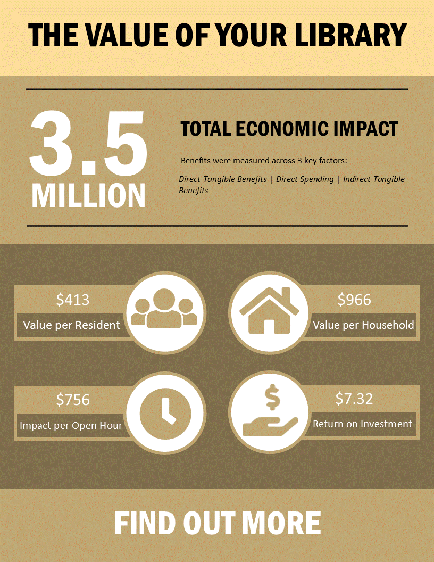

Economic Return on Investment
In addition to SROI, we have also examined the Economic Return on Investment (ROI) of the Library. The ROI study used the template provided by the Toronto Public Library (TPL) and the Martin Prosperity Institute (MPI). For every dollar spent by the municipality on the Library in 2017, the community received $7.32 economic benefit and a return on investment of 632%. For every hour we were open, $756 in benefit was generated. Additionally, the economic impact for each household was $966 last year.

What is Economic Return on Investment?
ROI is a cost-benefit approach to assessing how much was gained by an individual or organization relative to how much they invested. In 2013, MPI and TPL devised a study examining the economic impact of the TPL. Their study and the calculations used are easily adaptable to our library. The study examined the direct tangible benefits generated by the use of our programs, services, space, and collections as well as the intangible benefits generated by our spending.

Direct Tangible Benefits
Within the study, direct tangible benefits are those benefits which community members reap themselves. It’s the money they save by using our collections, services, space and programs. In order to present an accurate picture of the benefits accrued by the community two different discounts were applied to the retail value of each item in order to generate low (20% of the retail price), middle (60% of the retail price), and high (full retail price) values of economic impact. The market values used in the study were those established in the SROI study, any exceptions have been noted.

Use of Collections and In-Library Use
Our community benefits from our collections in many ways. They benefit when they check materials out, but also when they use them in the Library. Our collections provide entertainment and learning - the ability to relax while watching a movie in the evening, a story for a family to read at bedtime, or even a new recipe to try for the weekend. One patron recently commented “I got a library card last month after over 15 years without one. So nice to read as many books as I want without buying them.” Community members who cannot visit the Library in person also benefit through the cost-savings of our book delivery service to Rainycrest and the Manors.
Table 10: Economic benefit of collection use
Collection Use (All Formats and Audiences) | Circulation | Retail Value | Low  (80% Discount) | Midpoint  (40% Discount) | High  (No Discount)
Circulation | 88285 | $6.99-$119 | $515,534 | $1,532,292 | $2,549,049
In-House Use | 2919 | $0.45-$912 | $64,399 | $193,196 | $321,994
Materials Delivery | 4610 | $2.50 | $11,525
Total economic benefit of Collection Use | 95,814 |  | $591,458 | $1,737,013 | $2,882,568
The economic benefit we generated for the community through the use of our collections in 2017 totals $1,737,013, based on the ROI indicators.

Programs
The vast majority of library programs are free. When a charge is made for a program the cost is based on a cost recovery model for our more expensive programs. Economic benefit is provided to the community through this provision of entertainment. Library programs do not offer entertainment alone, with many programs supporting skills development, especially pre-literacy and literacy skills. To quote a community member “[The Library is] an amazing place for people of all ages to grow, learn and participate in community programs.” The ROI study only examines the economic benefit derived from programs and does not capture the many additional benefits library programming offers the community unlike SROI.
Table 11: Economic benefit of Program Attendance
Program Attendance | Attendees | Market Value | Total Economic Value
Cultural Programs | 504 | $30 | $15,120
Children and Youth Programs | 5437 | $15 | $81,555
Class Visits | 1917 | $50 | $95,850
Skills/Community Development | 5169 | $25 | $129,225
Adult Programs | 1069 | $20 | $21,380
Total economic benefit of Program Attendance | 14096 |  | $343,130
The economic benefit generated for the community through program attendance in 2017 totals $343,130 based on the ROI indicators.

Reference and Database Services
Despite the many changes to library services over the past few years, our role as an information provider remains one of our most vital services. There is an economic impact to having access to both vetted information sources as well as a person to help navigate the information overload that exists within the digital age. Staff are able to assist patrons with finding the right information and in learning how to use the many digital and technological tools available at the Library. In a recent survey, one person responded “… staff are very open and friendly and will find a way to correctly answer the questions I have, suggest books similar to the ones I like and has a variety of things that I can do other than read a book.”
Table 12: Economic benefit of Information Requests and Database Searches
Information Requests and Database Searches | Number | Market Value | Total Economic Value
Reader’s Advisory | 1450 | $25 | $36,250
Reference Requests | 1050 | $25 | $26,250
ICT Requests | 1750 | $25 | $43,750
Database Searches | 3892 | $25 | $97,300
Total economic benefit of Information Requests and Database Searches | 4071 |  | $203,550
The economic benefit generated for the community through the use of our online resources and information services in 2017 totals $203,550 based on the ROI indicators.

Technology Access
Access to the internet and computers is now considered a basic service. Due to the costs of service or a lack of availability however, many people experience barriers to accessing what has become an integral part of our every day lives. A lack of internet service can lead to both financial loss as well as a lowered quality of life (EKOS, 2016). The Library offers a bridge across the digital divide by providing free access to both the internet and computers to our community members. One person responded in our survey that “I use the internet connection because the Internet where I live is unreliable.” There is a very clear economic impact associated with providing our community access to the internet as shown in Table 13.
Table 13: Economic benefit of Technology Access
Technology Access | Number | Market Value | Total Economic Value
Computer Access | 10,962 | $5 | $54,810
Wi-Fi Usage | 13,536 | $5 | $67,680
Total economic benefit of Technology Access | 24,498 |  | $122,490
The economic benefit generated for the community through the access to technology we provided in 2017 totals $122,490 based on the ROI indicators.

Meeting and Study Space
The community receives an economic benefit from the use of our space, which is used for studying or conducting business. We provide a comfortable environment with fast internet speed, which is vital to today’s businesses and students. Someone commented recently “I mostly come here for a place to be, it’s a good quiet environment for getting some reading or getting some work done. I use the rooms when I have webinars or need to do online tests.”
Table 13: Economic benefit of Meeting and Study Space
Meeting and Study Space | Number of Hours/Visitors | Market Rate/Hour | Total Economic Value
Room Rentals | 2,296 | $12.20-$17 | $31,379
Study Space Usage | 45,949 | $4 | $183,798
Total economic benefit of Meetings and Study Space | 48,246 |  | $183,798
The economic benefit generated for the community by the access to study and meeting spaces we provided in 2017 totals $183,798 based on the ROI indicators.

Value of an Open Hour
Our community gains significant economic value for each hour that the Library is open in a year. Many of the benefits we provide can only be accessed during open hours. Past history has proven that the fewer hours we are open, the less our services are used. When there was a reduction in Library hours of 16% in 2012 the number of annual visits to the Library dropped by 25%. The more accessible our services are, the more they are used, and the more value we are able to provide our community.

Table 13: Economic impact of an Open Hour
Value of an Open Hour | Low | Midpoint | High
Total Economic Benefit | $1,111,441 | $2,256,995 | $3,402,550
Open Hours | 2984
Value of an Open Hour | $372.47 | $756.37 | $1,140.26
In order to calculate the economic impact each open hour has on the community the benefits that are a direct result being open were totaled and then divided by the number of hours we are open. The results show that we had an economic impact of $756.37 for each hour we were open in 2017.

Indirect Tangible Benefits
The community receives indirect economic benefits related to our spending. Through our operational purchases, capital investments, materials spending, and salary expenditures, we are able contribute to the economic wellbeing of the community. In addition to actual expenditures, the study also applied value to the employment experience gained by Library pages.
Table 14: Indirect Tangible Benefits
Indirect Tangible Benefits | Low  (60% Discount) | Midpoint  (30% Discount) | High  (Actual Costs)
Operational | $50,919 | $89,108 | $127,298
Capital | $12,978 | $22,712 | $32,446
Employment | $158,409 | $277,217 | $396,024
Materials | $22,340 | $39,095 | $55,850
Pages Employment Experience | $5,390 | $9,433 | $13,476
Total Indirect Tangible Benefits | $250,037 | $437,565 | $625,093
The indirect economic benefit generated for the community by our expenditures totals $437,565 based on the ROI indicators.

The Economic Return on Investment of the Fort Frances Public Library Technology Centre
The ROI Study shows the economic benefits gained by our community through investment in the Library. The study focused on three areas: Direct Tangible Benefits, Direct Spending, and Indirect Tangible Benefits.
This study only focused the dollars saved by the community by using the Library, it does not reflect any of the additional benefits gained by the community through using our services the same way the SROI Study does. The ROI study therefore, only offers a partial picture of the benefits of library services. That being said even looking at only the more narrowly focused ROI study, there is clear and demonstrated economic value to library services.

Table 14: ROI for the Fort Frances Public Library Technology Centre
Economic Return on Investment Data |  | Low | Midpoint | High
Direct Tangible Benefits | Collection Use | $591,458.14 | $1,737,012.91 | $2,882,567.69
 | Programs | $343,130.00
 | Reference and Database Services | $203,550.00
 | Technology Access | $122,490.00
 | Meeting and Study Space | $215,176.54
 | Total Direct Tangible Benefits | $1,475,804.68 | $2,621,359.45 | $3,766,914.23
Direct Spending | Operations | $127,297.55
 | Capital (annual average) | $32,445.92
 | Employment | $396,023.59
 | Materials | $55,849.70
 | Total Gross spending | $611,616.76
 | Revenue Offsets to Costs | $127,400.10
 | Total Direct Spending | $484,216.66
Indirect Tangible Benefits | Operations | $50,919.02 | $89,108.29 | $127,297.55
 | Capital (annual average) | $12,978.37 | $22,712.14 | $32,445.92
 | Employment | $158,409.44 | $277,216.51 | $396,023.59
 | Materials | $22,339.88 | $39,094.79 | $55,849.70
 | Pages Employment Experience Benefits | $5,390.40 | $9,433.20 | $13,476.00
 | Total Indirect Tangible Benefits | $250,037.10 | $437,564.93 | $625,092.76
Total Economic Impact |  | $2,210,058.44 | $3,543,141.04 | $4,876,223.65
Impact per Dollar Spent |  | $4.56 | $7.32 | $10.07
Impact per Resident (as defined in SROI) |  | $257.37 | $412.62 | $567.86
Impact per Household (as defined in SROI) |  | $602.52 | $965.96 | $1,329.40
Total Benefits |  | $1,725,841.78 | $3,058,924.38 | $4,392,006.99
Return on Investment |  | 356% | 632% | 907%
Average Value of One Open Hour |  |  | $756.37
Our community is able to benefit greatly from an excellent return on investment. The tax dollars spent supporting the Library’s services lead to an economic impact of $7.32 per dollar spent and a return on investment of 632%. The total economic impact of the Library is $3,543,141.
For every hour that the Library was open in 2017 the community gained $756 in value, while the per hour cost to run the Library was only $162. The difference in value gained versus cost remains significant. Library members enjoy significant benefits that are derived from using our services. Many of the social benefits were outlined in the SROI section of this report. In addition to the social benefit of memberships, the economic value of a library membership is $578. These studies have shown that an investment in the Fort Frances Public Library Technology Centre offers many returns and is a wise investment.

References
Brewster, L. (2014). The public library as therapeutic landscape: A qualitative case study. Health & Place, 26, 94-99.
Canadian Council on Learning (2010). State of learning in Canada: A year in review 2009-2010. Ottawa, ON: Author.
Canadian Library Association (2014). The status and future of Canada’s libraries and archives: The Canadian Library Association’s response to the consultation of the Royal Society of Canada’s expert panel. Toronto: Author.
EKOS Research Associates Inc. (2016, March 18). Let’s Talk Broadband Findings Report (Canada, Canadian Radio-television and Telecommunications Commission). Retrieved January 27, 2018, from http://epe.lac-bac.gc.ca/100/200/301/pwgsc-tpsgc/por-ef/crtc/2016/030-15-e/report.html
Hanna, L. (2012). Homeschooling education: Longitudinal study of methods, materials, and curricula. Education and Urban Society, 44(5), 609-631.
Lingane, A. & Olsen, S. (2004). Guidelines for social return on investment. California Management Review, 46(3), 116-135.
Martin Prosperity Institute [MPI] (2013). So much more: The economic impact of the Toronto Public Library on the City of Toronto. Toronto: Author
Rankin, C. (2012). The potential of generic social outcomes in promoting the positive impact of the public library: Evidence from the National Year of Reading in Yorkshire. Evidence Based Library and Information Practice​, 7(1), 7-21.
Rao, G.C. (2012). The Great Equalizer: The case for investing in the Toronto Public Library. Toronto: Canadian Centre for Policy Alternatives.
Rosenfeldt, D. (2006). Libraries building communities: The vital contribution of Victoria’s public libraries. Performance Management and Metrics, 7(3), 185-192.
Ulvik, S. (2010). ‘Why should the library collect immigrants’ memories?’ A study of a multicultural memory group at a public library in Oslo. New Library World, 111(3/4), 154-160.
Wathen, C.N., Harris, R. M. (2007). “I try to take care of it myself” How rural women search for health information. Qualitative Health Research, 17(5), 639-651.

This premium is based on the percentage difference between the cost of a Nutritious Food Basket in Toronto versus the Northwest
The cost of a dial-a-Ride fare

