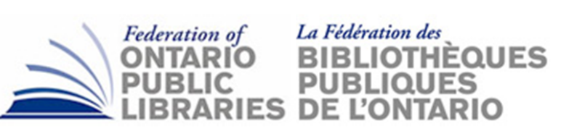
FOPL HR WORKING GROUP REPORT

Subject: FOPL HR Capacity Working Group Report
Date: Jan 9, 2019
Prepared by: Andrea Cecchetto
Prepared for: FOPL AGM, Jan. 31, 2019

The Human Capacity Working Group began meeting in 2018 with a mandate to investigate challenges and factors impacting leadership development for public libraries. Library sector leaders anticipate significant impact to the overall organizational capacity of the industry due to the retirement of the existing cohort of CEOs and other senior staff. Following research that suggested that only a small portion of library professionals are interested in CEO positions, there is significant concern about continuity of professional leadership. This concern is compounded by the perceived skill gap with new professionals and the risk that there is insufficient time for these individuals to gain appropriate leadership experience in preparation for senior roles. The FOPL Human Resources Capacity Working Group developed a mandate to address this issue of how to development the “soft middle” – the existing generation of leaders who will form the talent pipeline for CEO and senior positions.

In 2018, the working group sought to research attitudes and motivations of this group, and to assess their current state of leadership development. In year one of the group’s mandate, two surveys were conducted, one for emerging leaders and a second for CEOs. The survey identified the following:
• The importance of intangible benefits (e.g. flex time, remote work options, development opportunities etc.) for emerging leaders
• Preferences in workplace culture
• Motivational factors for advancement
• Self-identified leadership strengths and opportunities for development
• Interest in the CEO role
Following the administration of the emerging leaders’ survey, a mirror survey was issues for CEOs to compare and contrast how emerging leaders identified their own capacity and how the CEO’s assessed the capacity of their reports. Key findings from these surveys will be presented at the OLA Super Conference on February 1, 2019 but the Working Group members. For year two of the group’s mandate, the team will identify opportunities and potential interventions to address the survey findings.

